**Lab 5: Operational Amplifiers – Part 3**

Faizan Bangash

Ecen 325-504

Date: 10 October 2018

**Calculation**

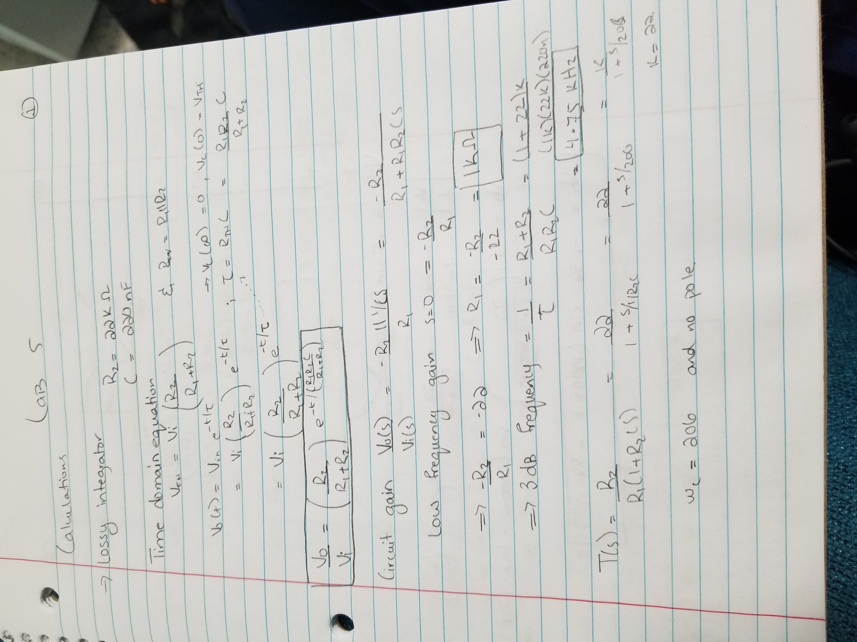

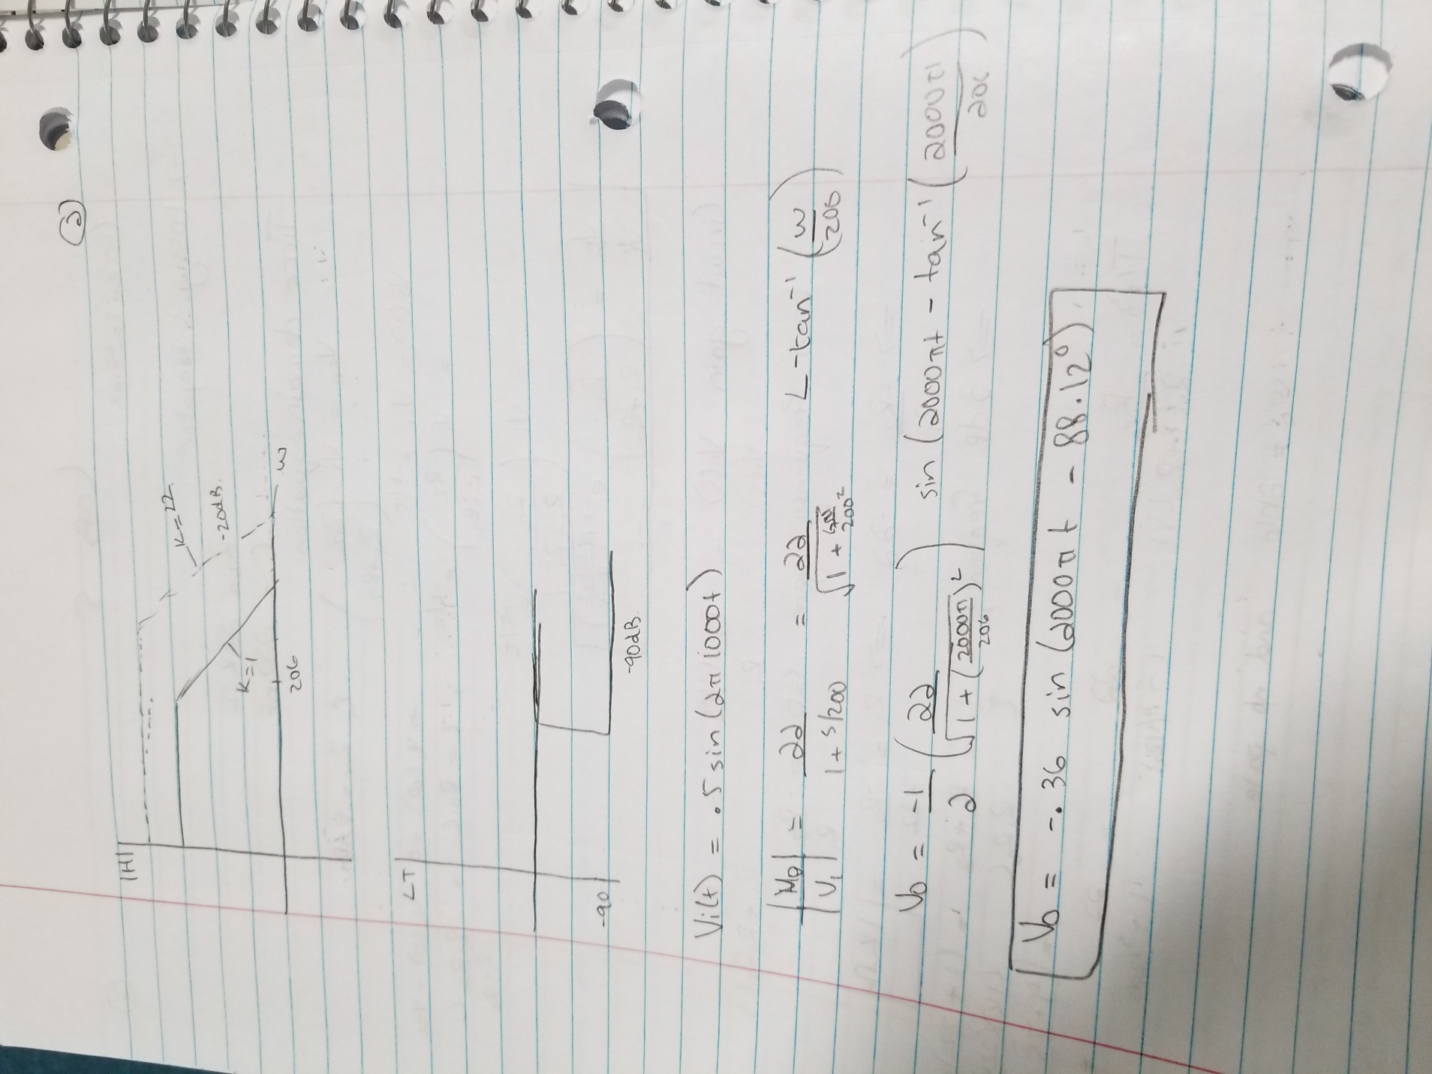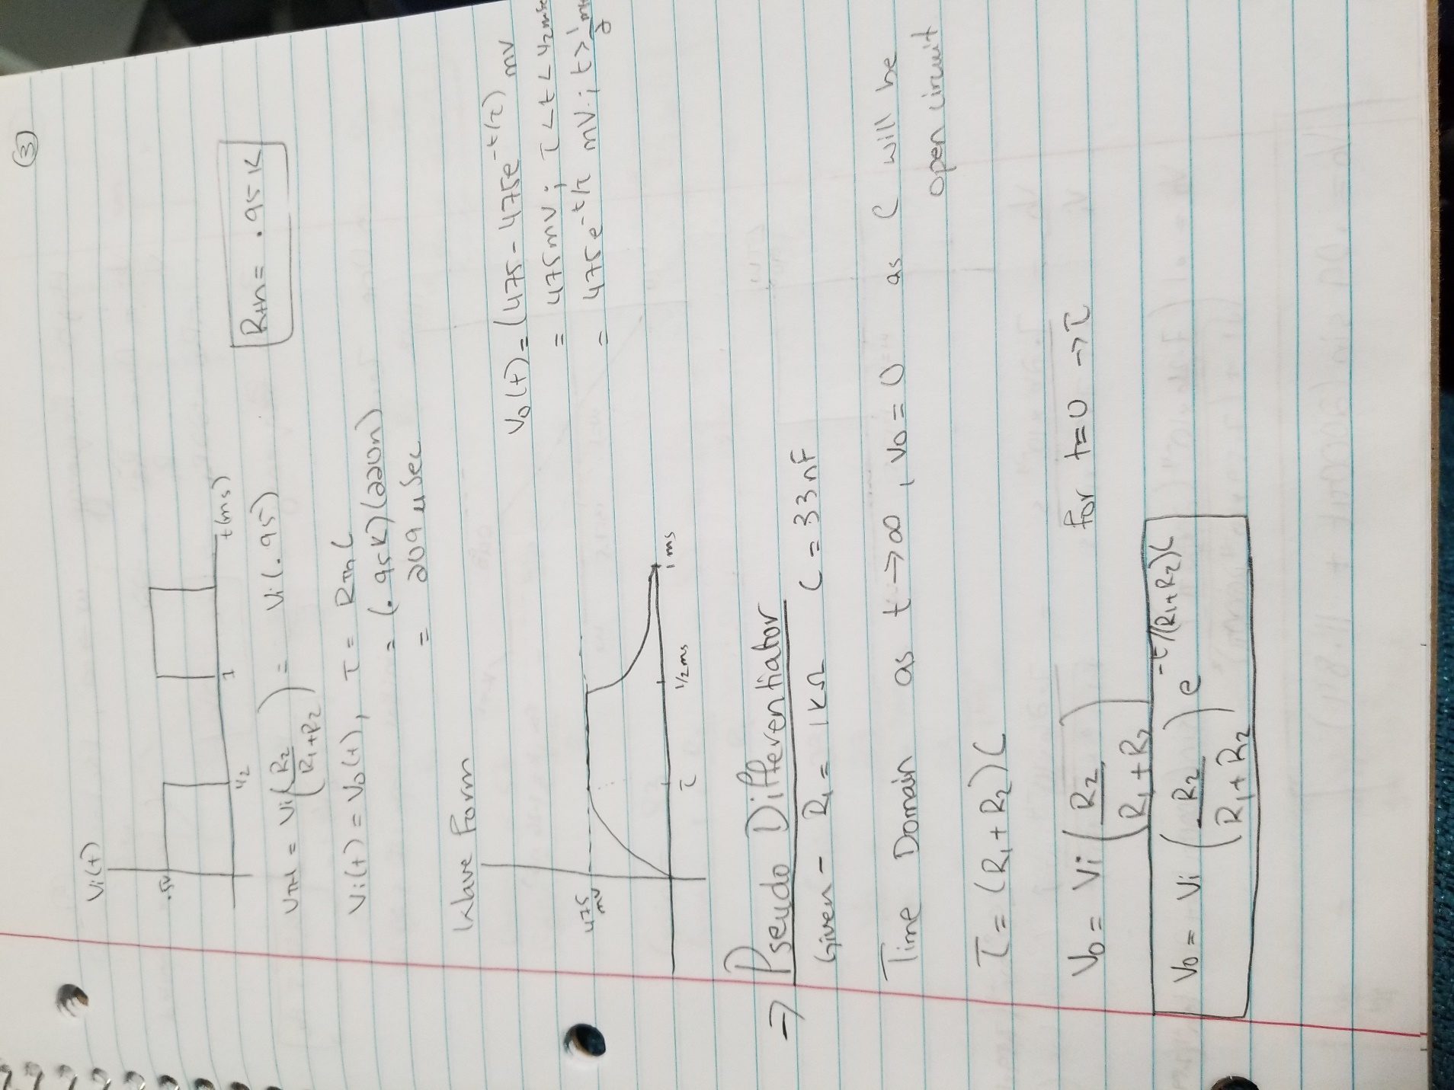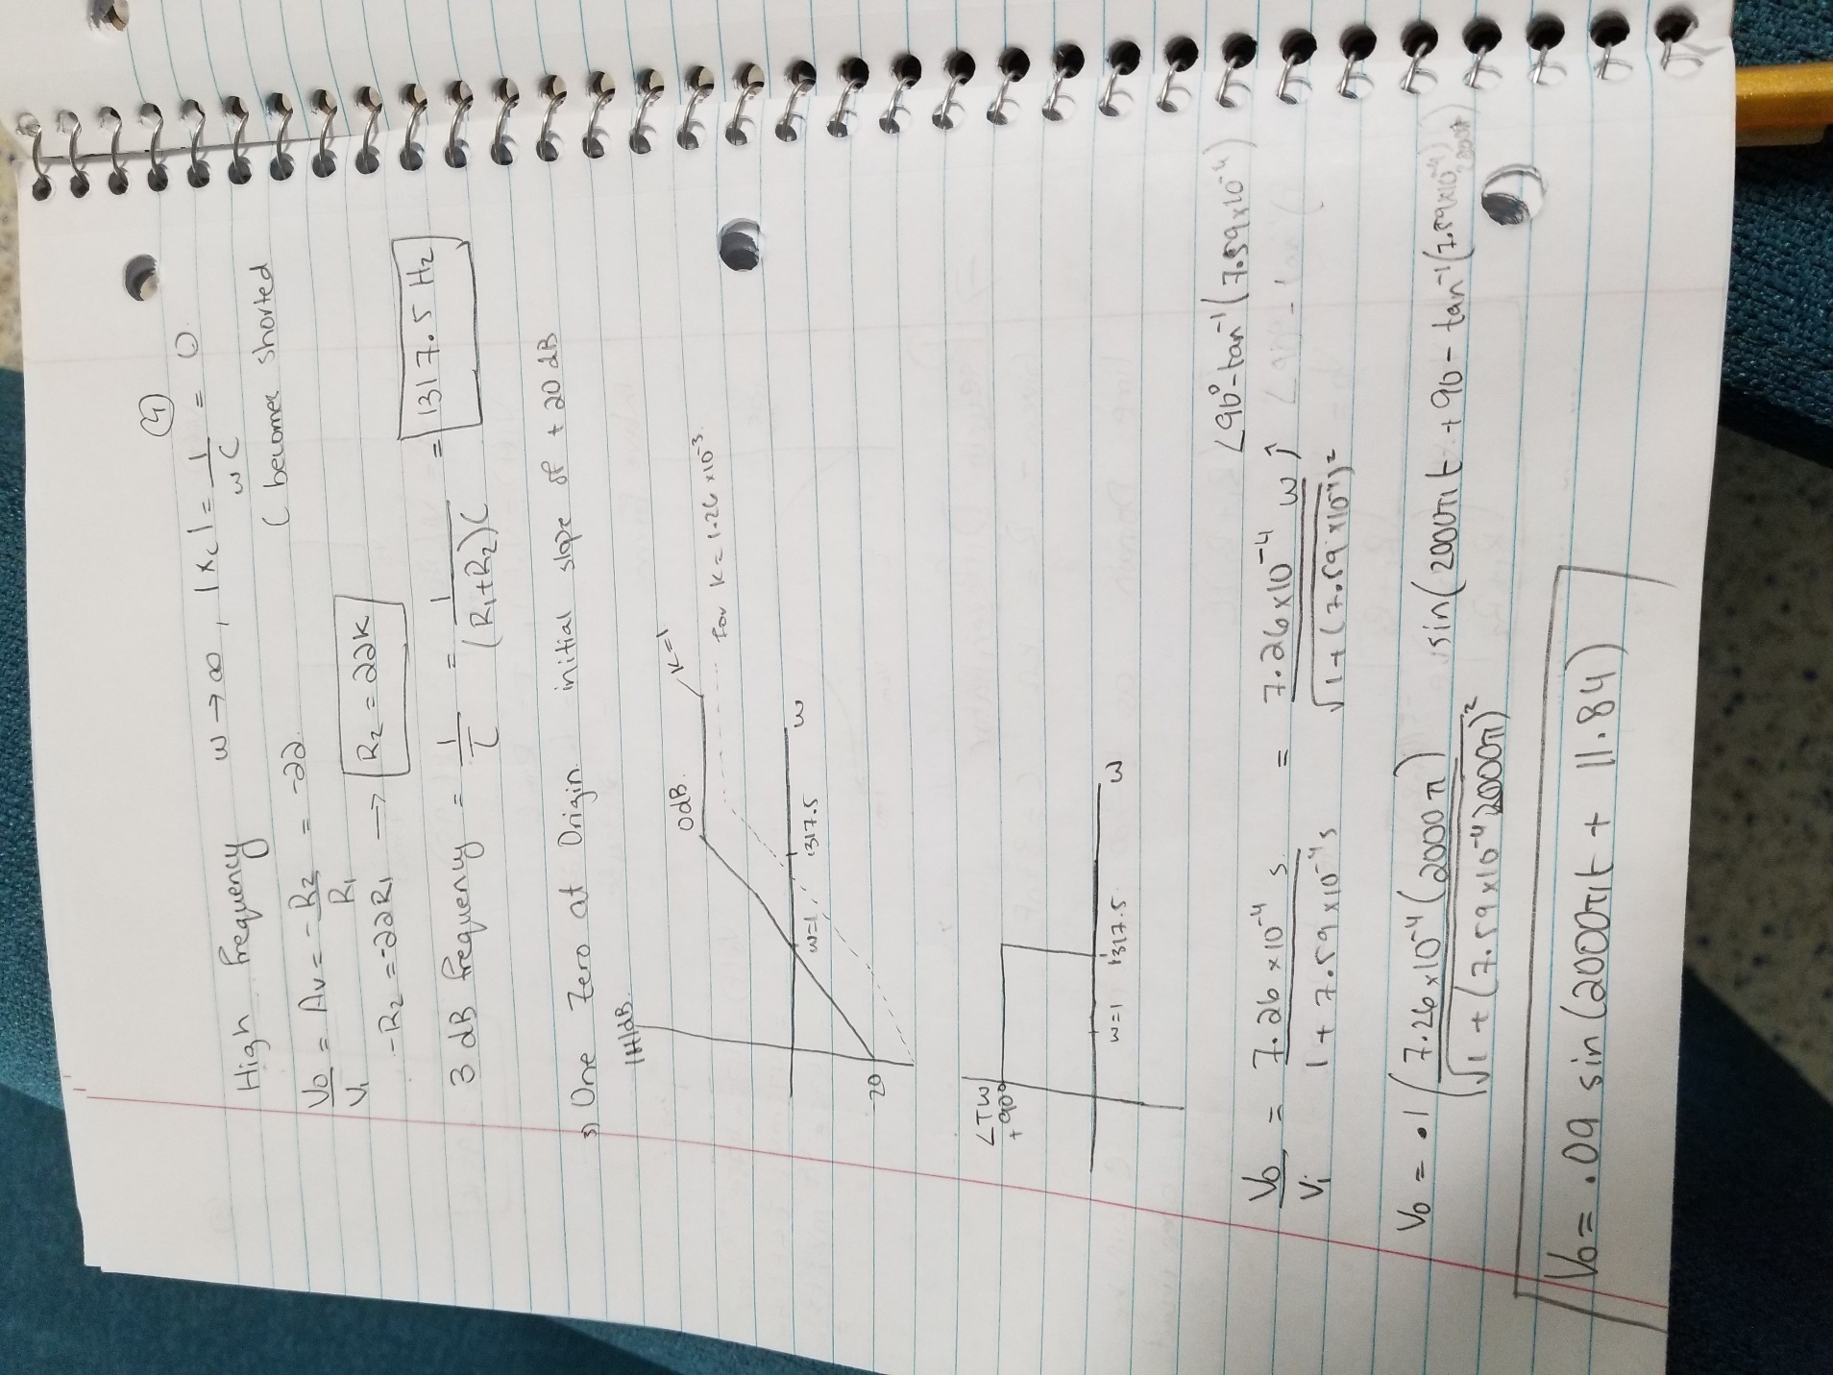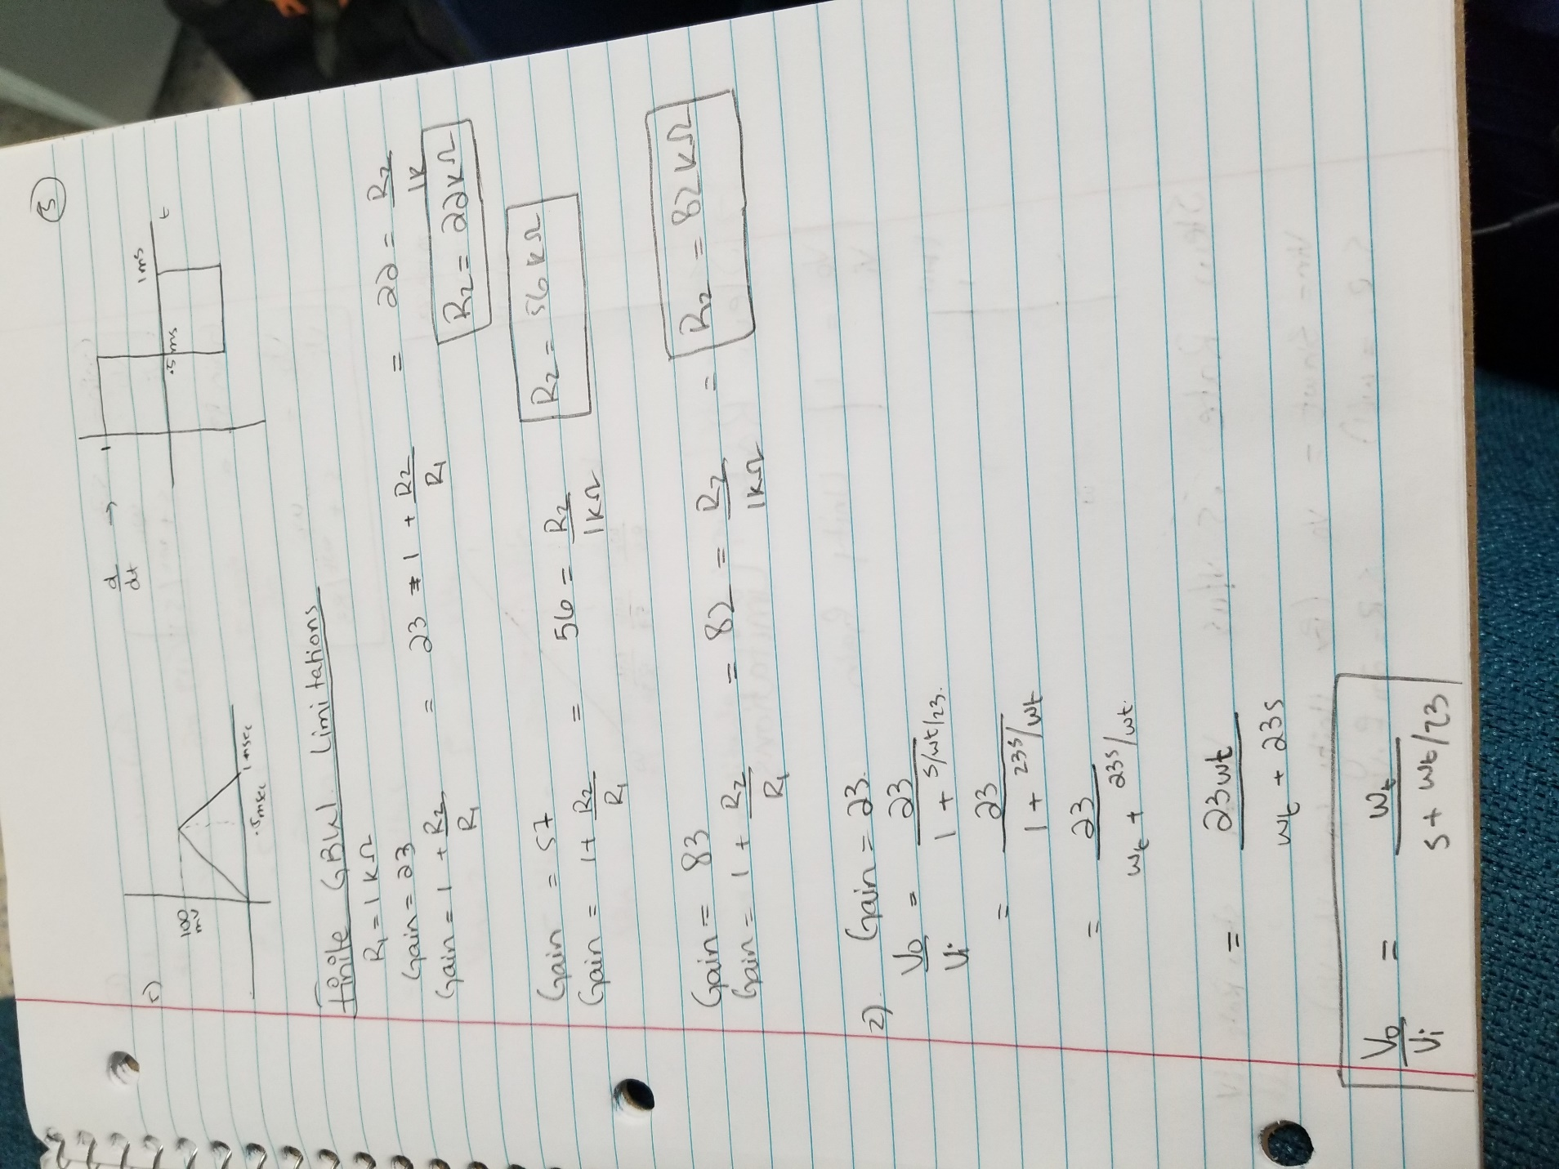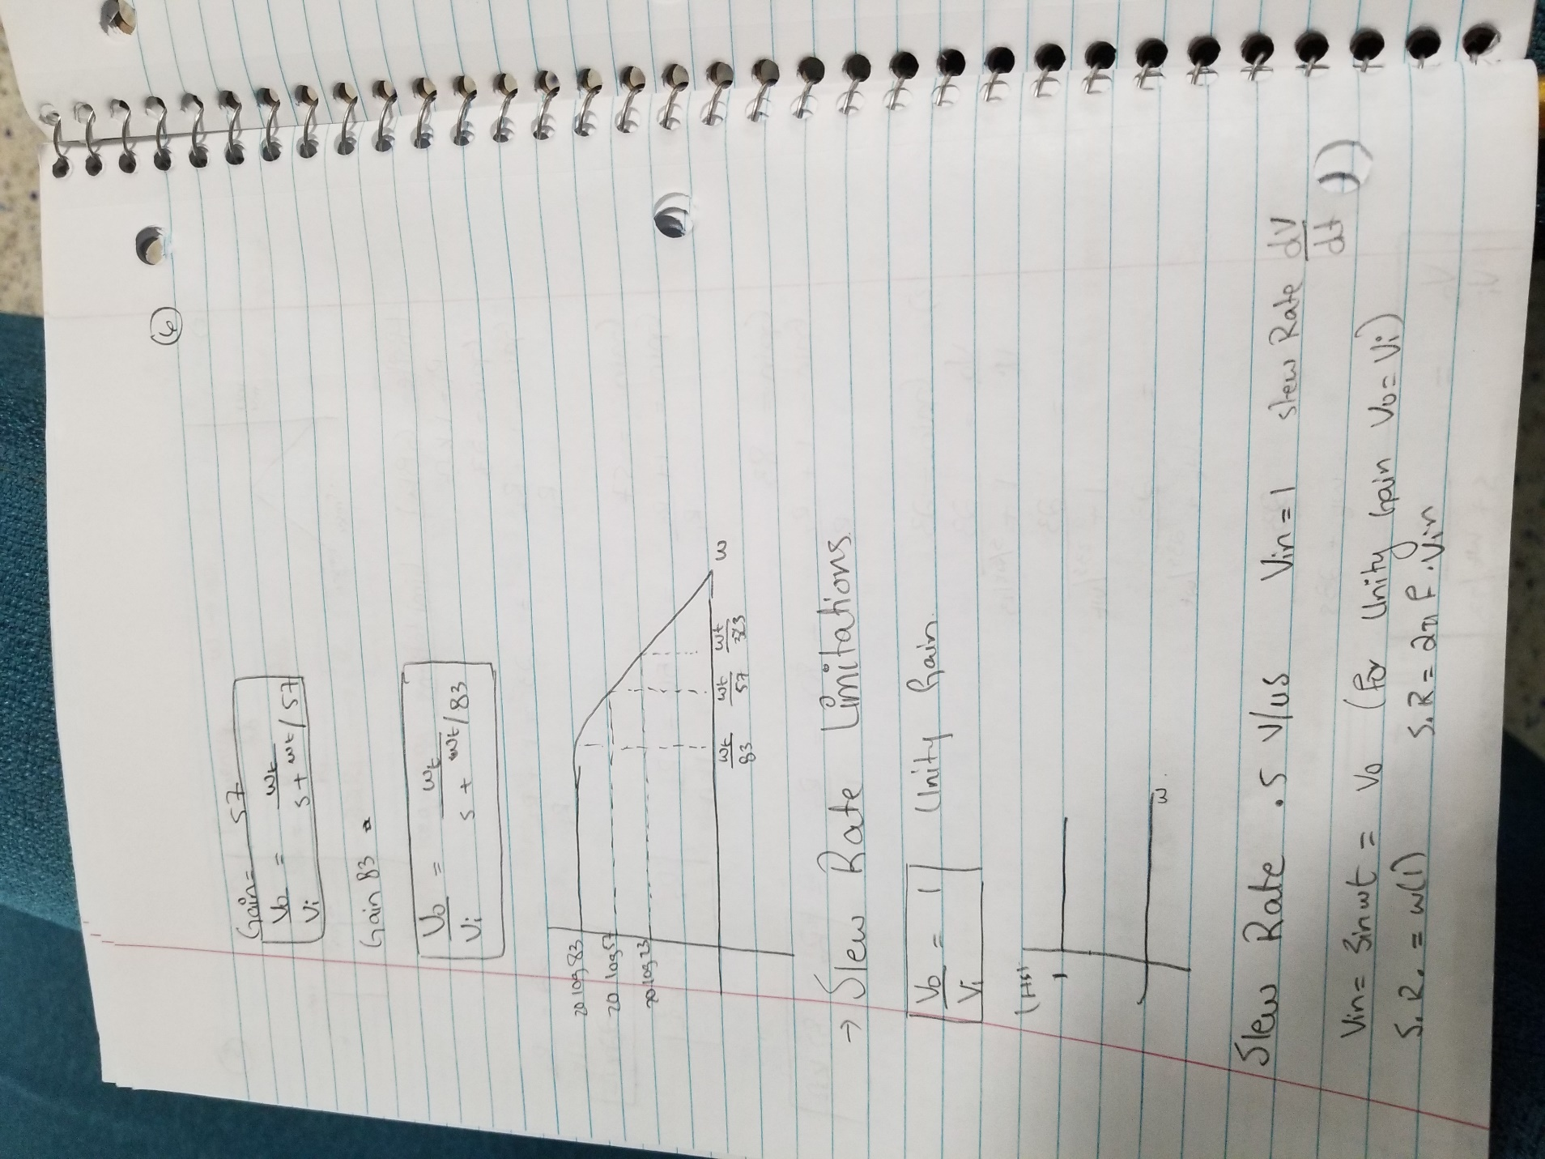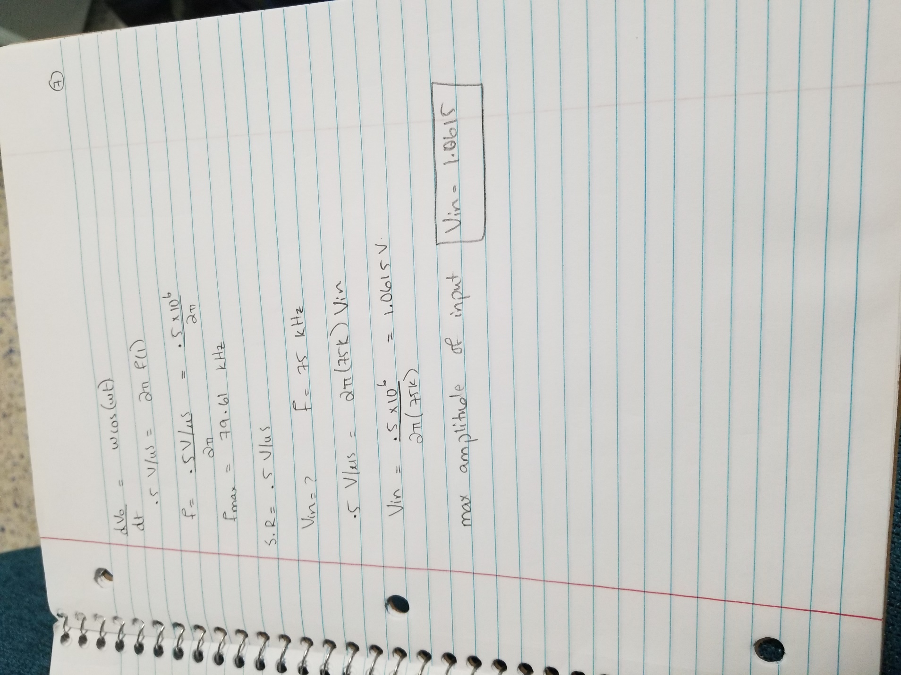

**Simulation**

**Integrator**

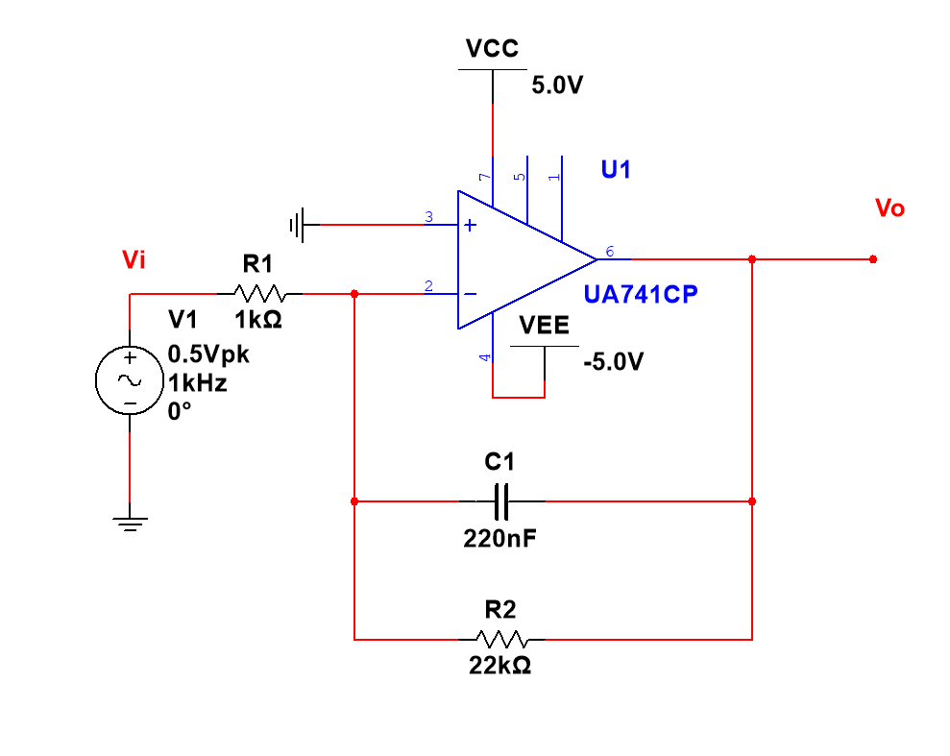

Bode Plots

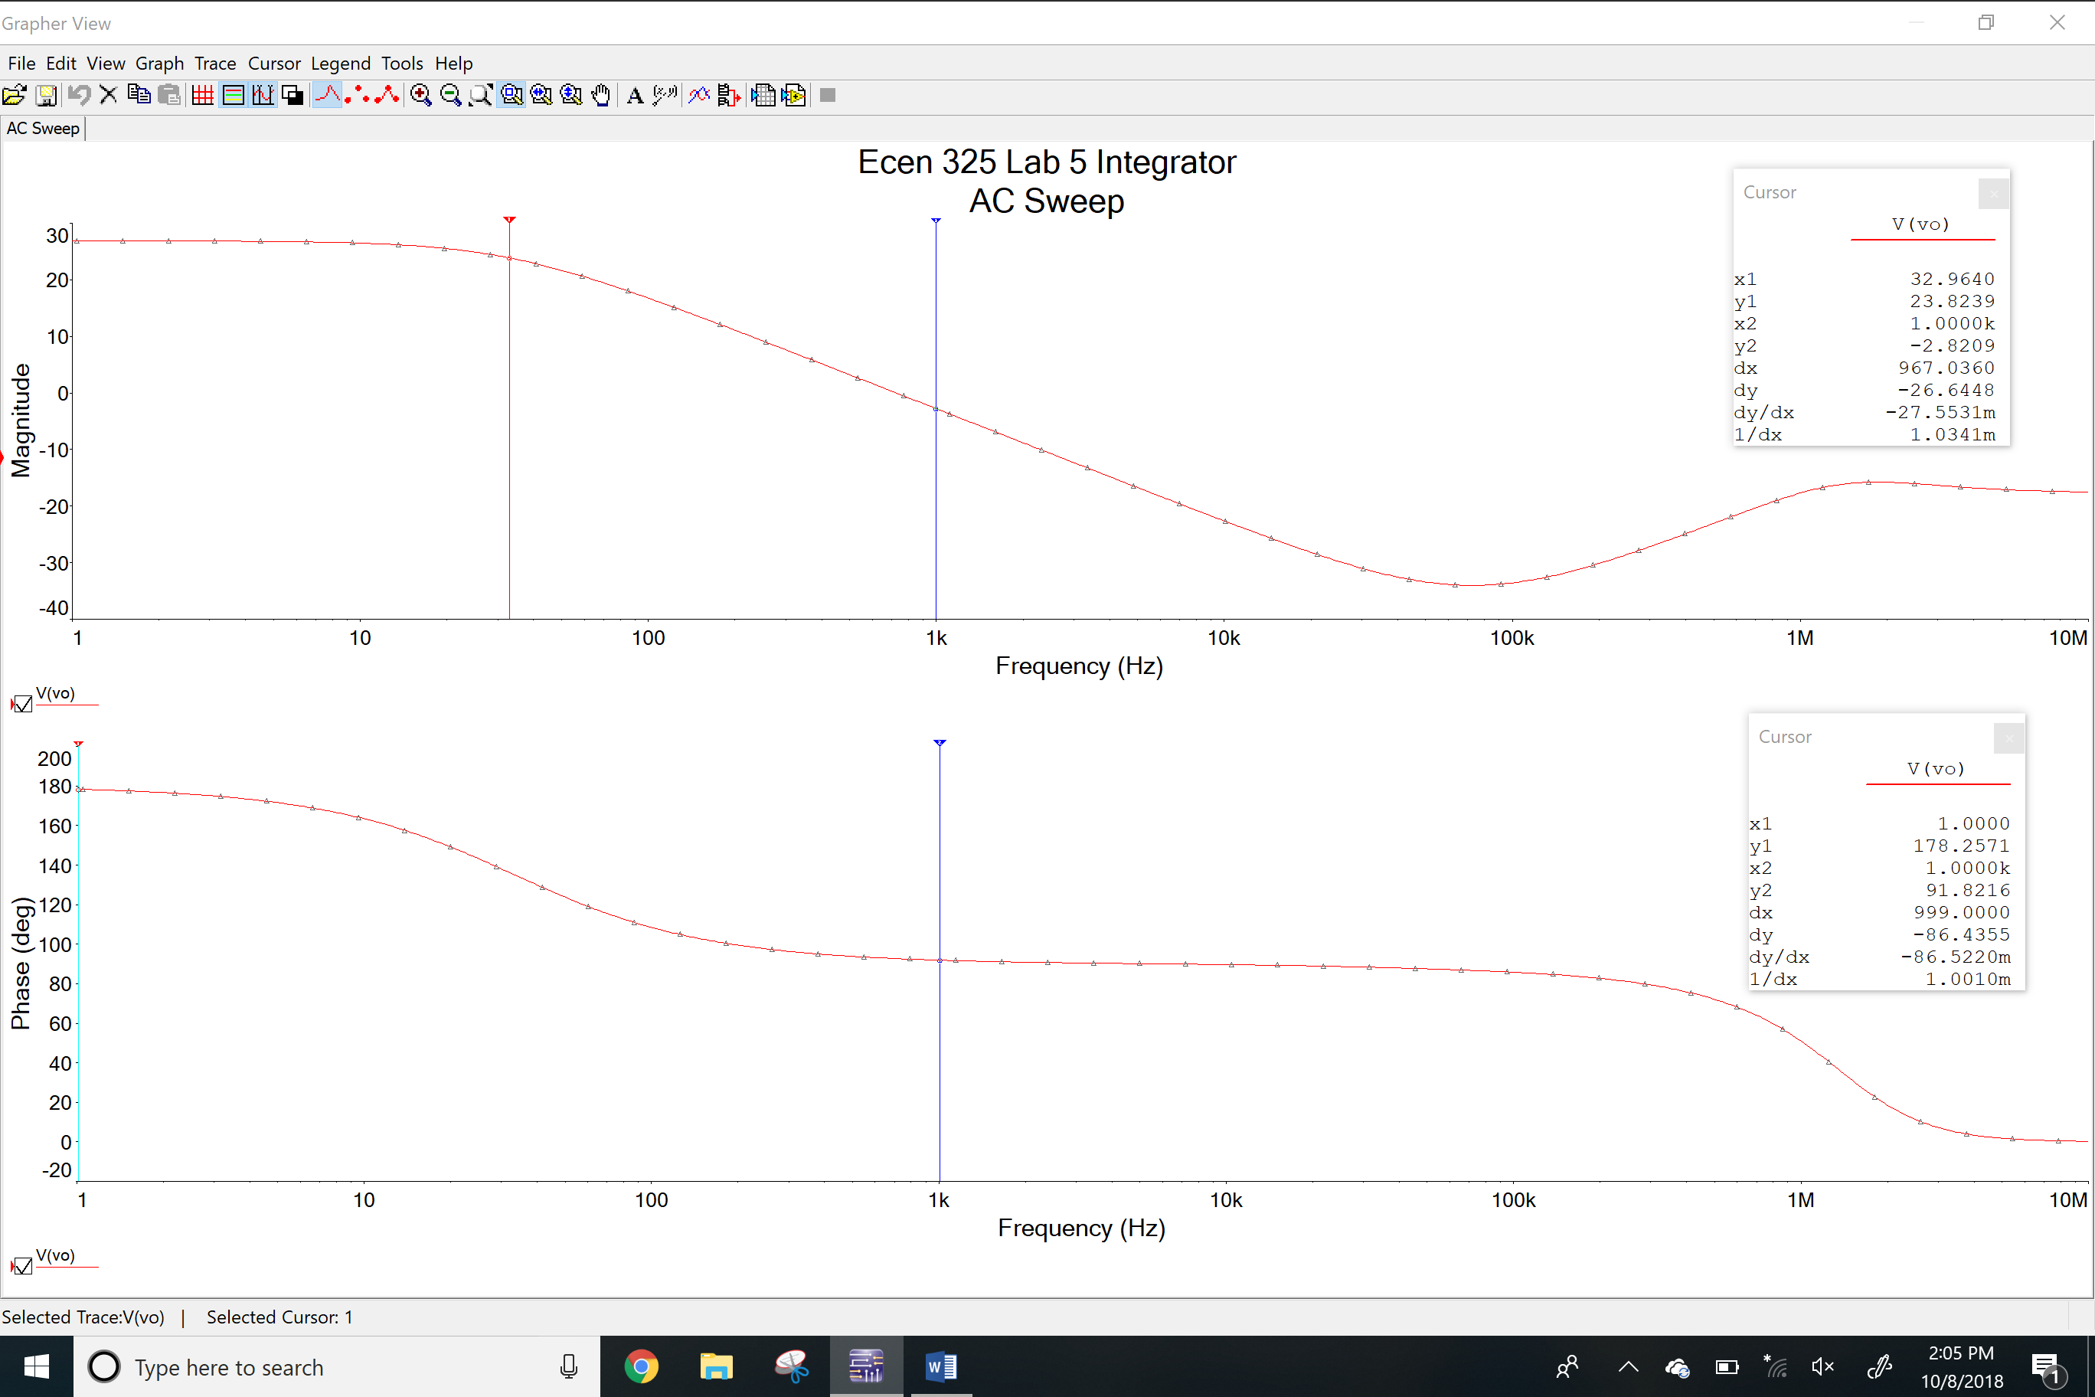

Time-domain waveform: sine wave

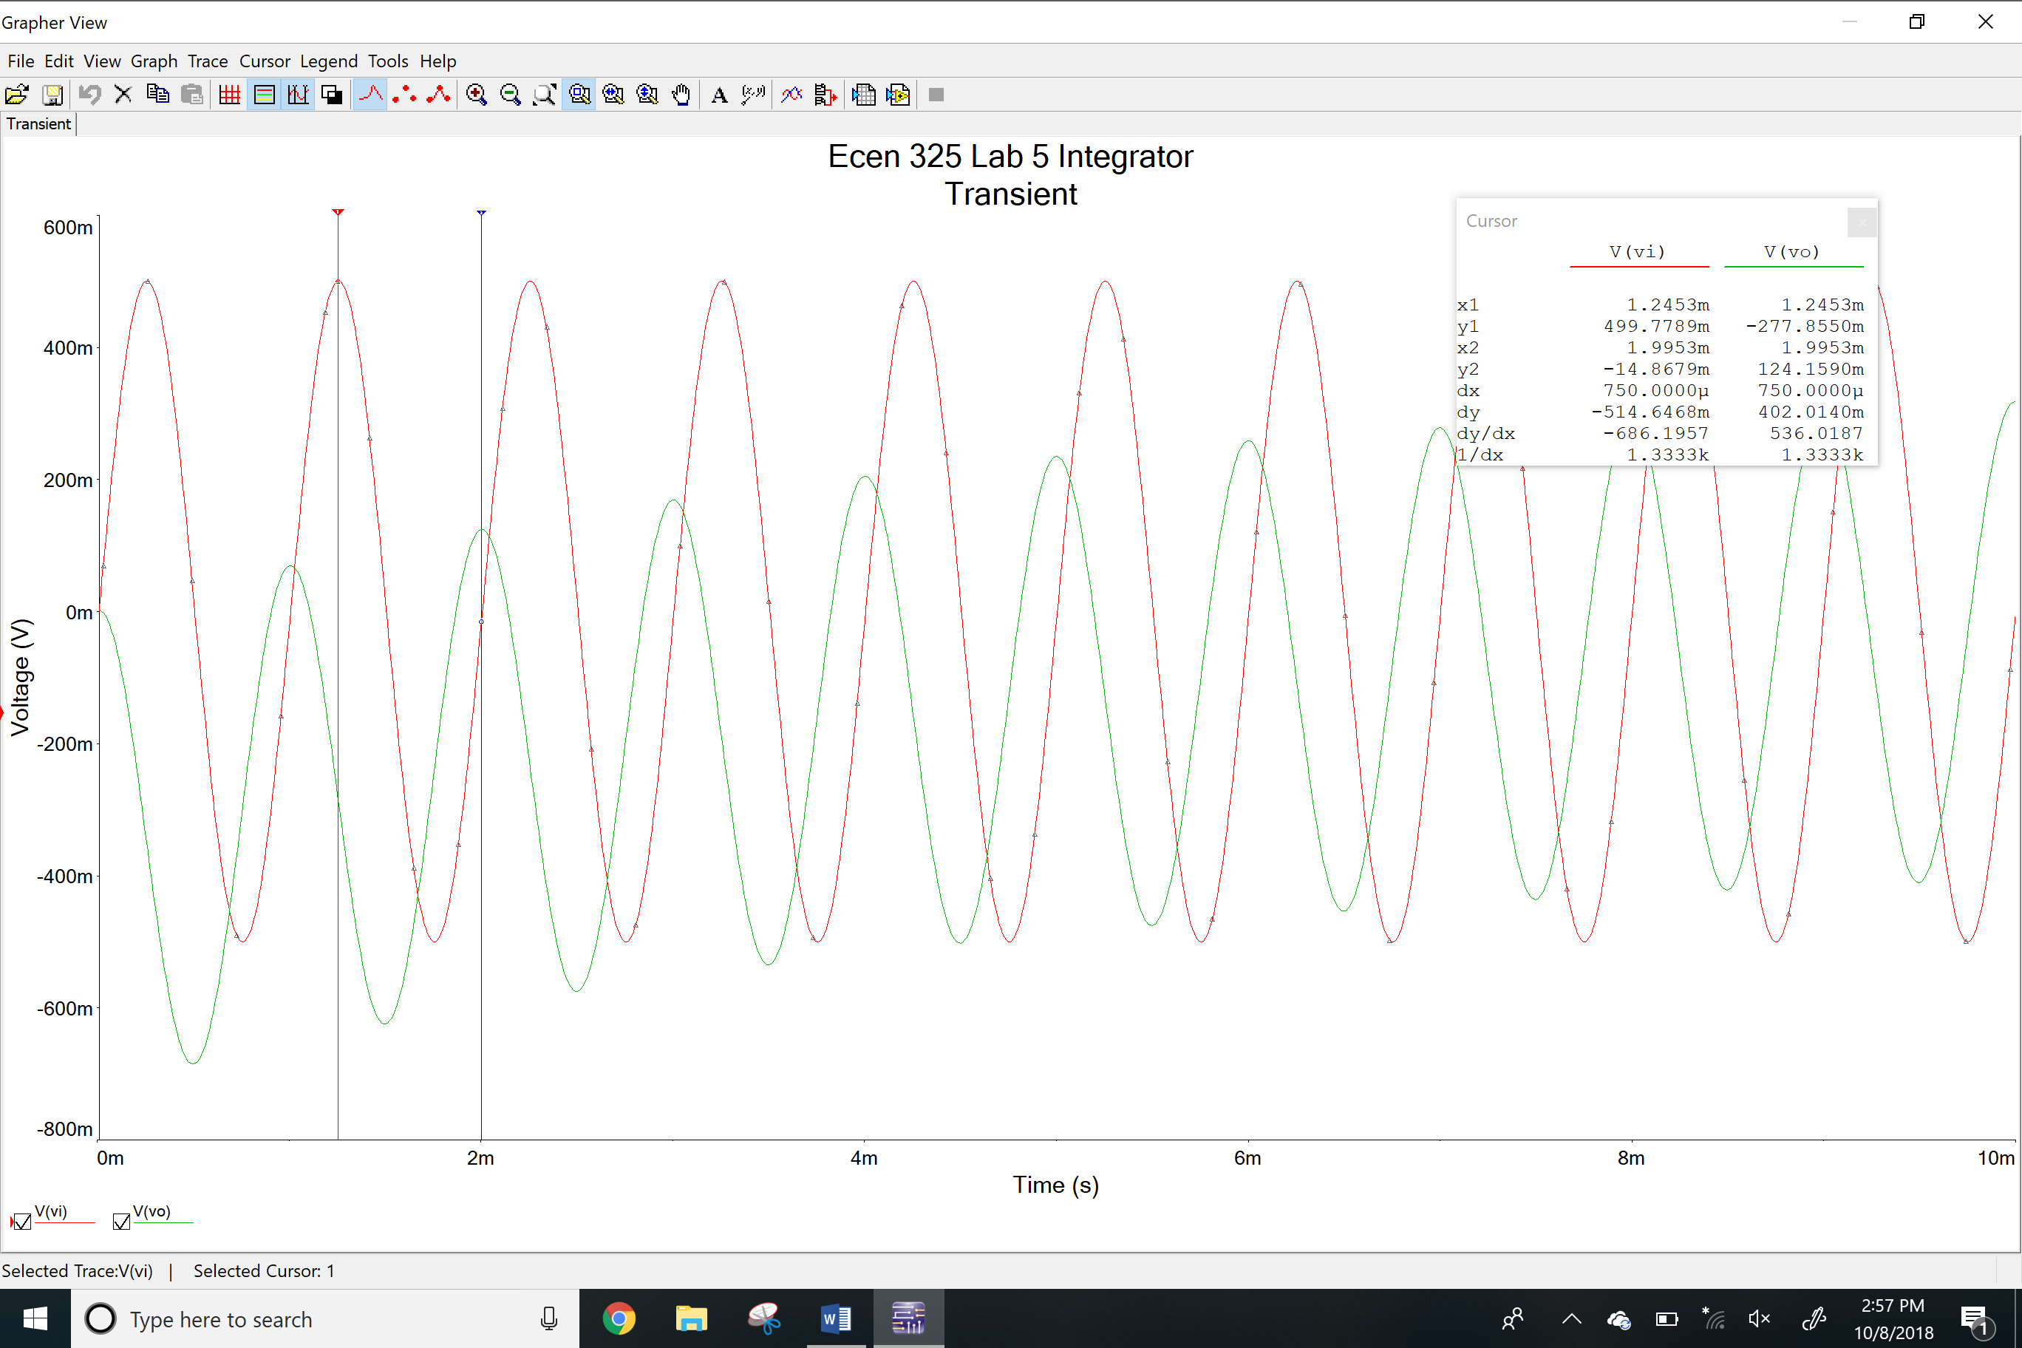

Time-domain waveform: square wave

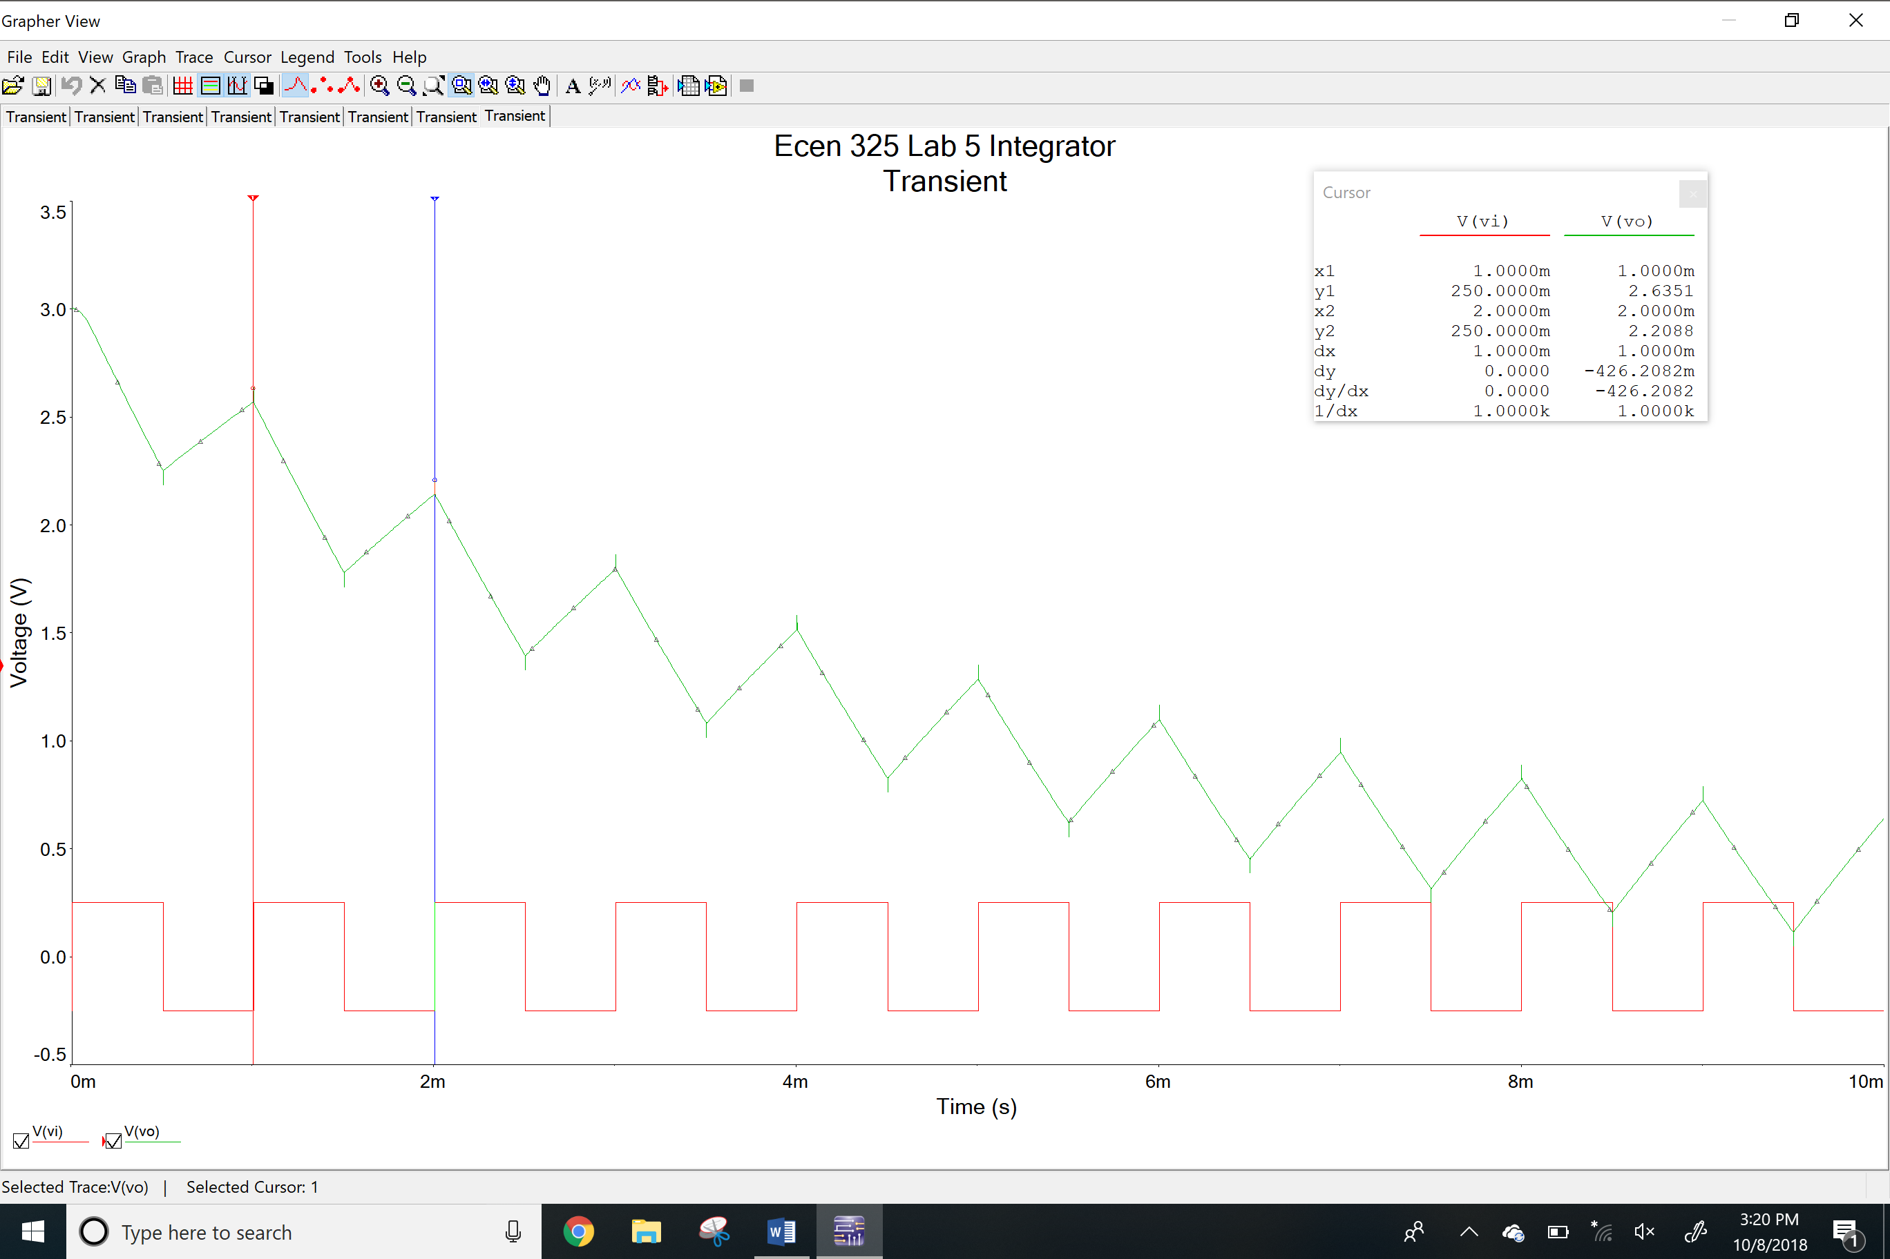

Removing resistor R2

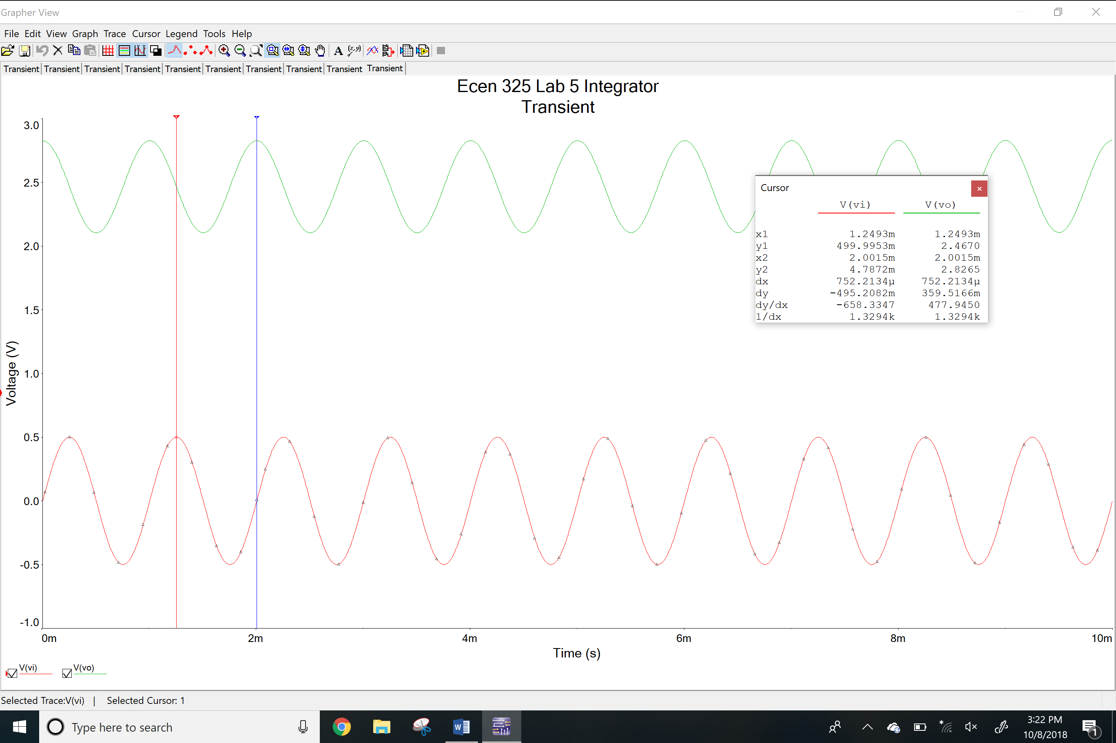

**Differentiator**

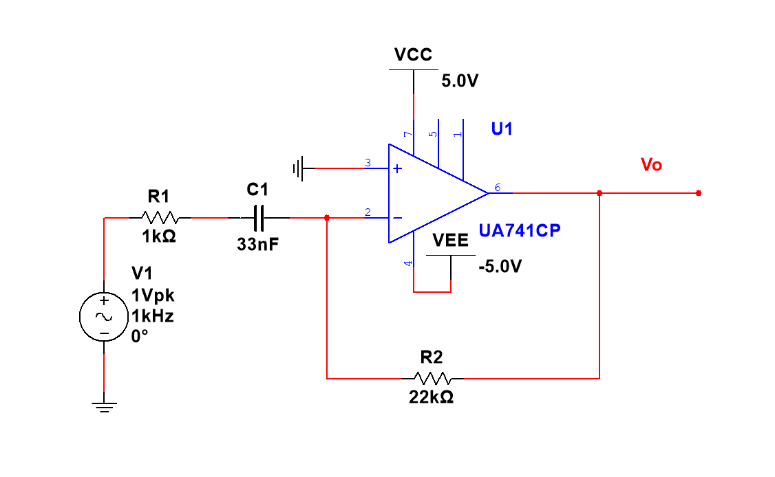

Bode Plots

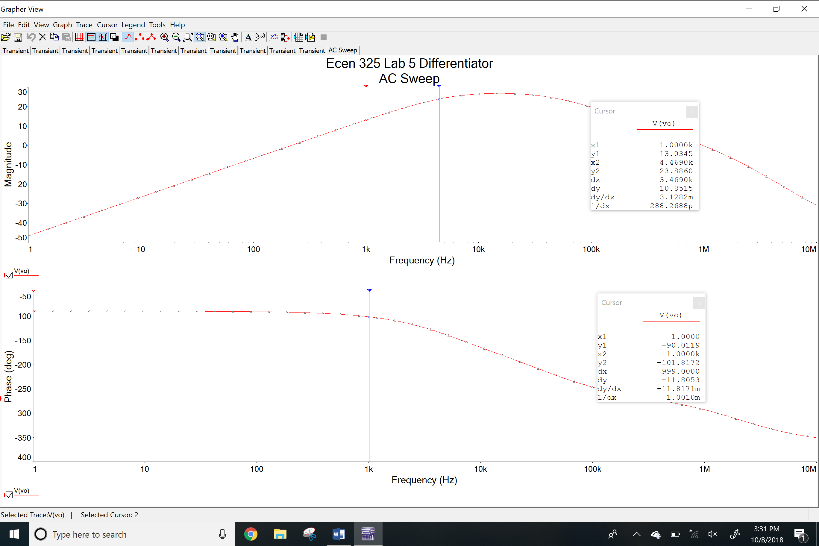

Time-domain waveform: sine wave

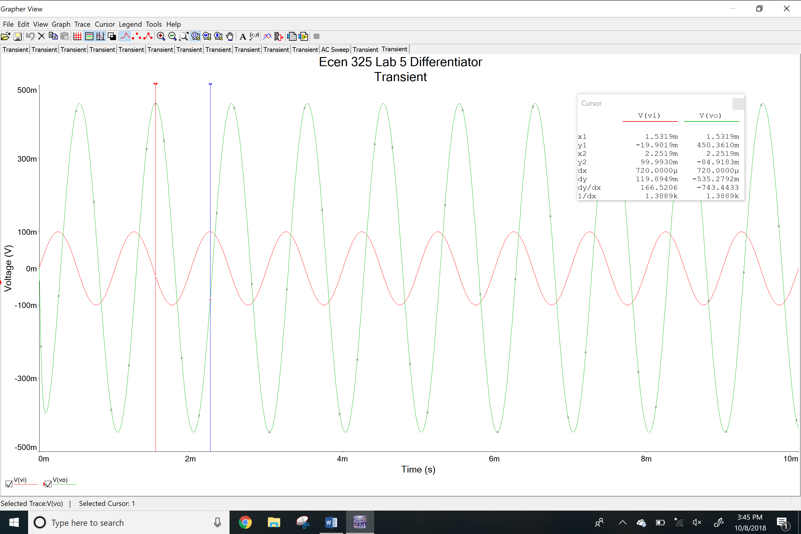

Time-domain waveform: triangle wave

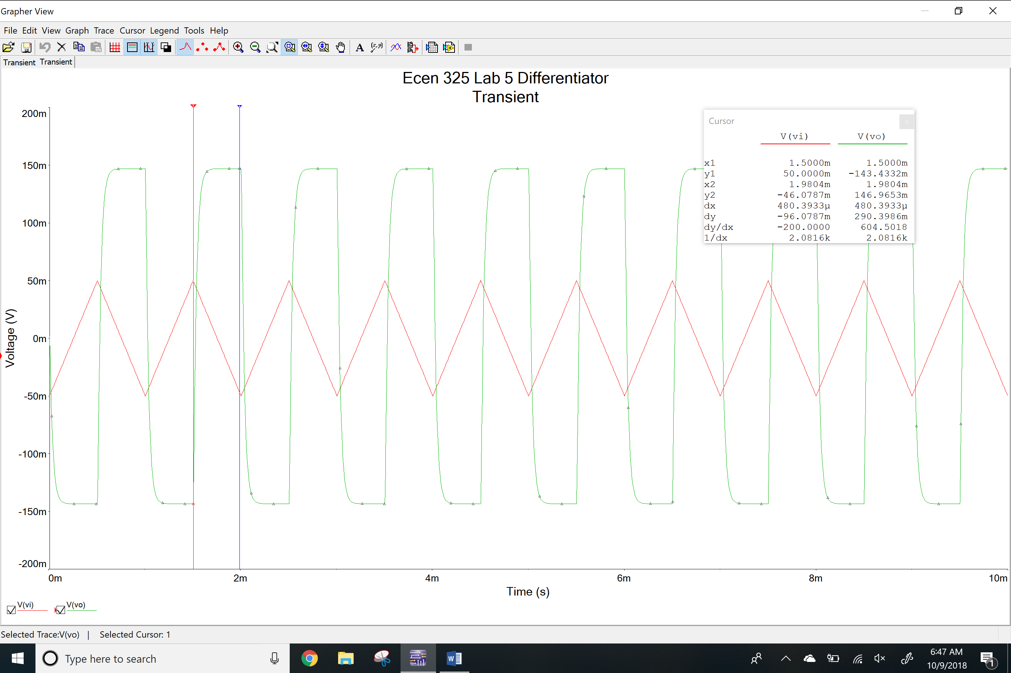

**Finite GBW Limitations**

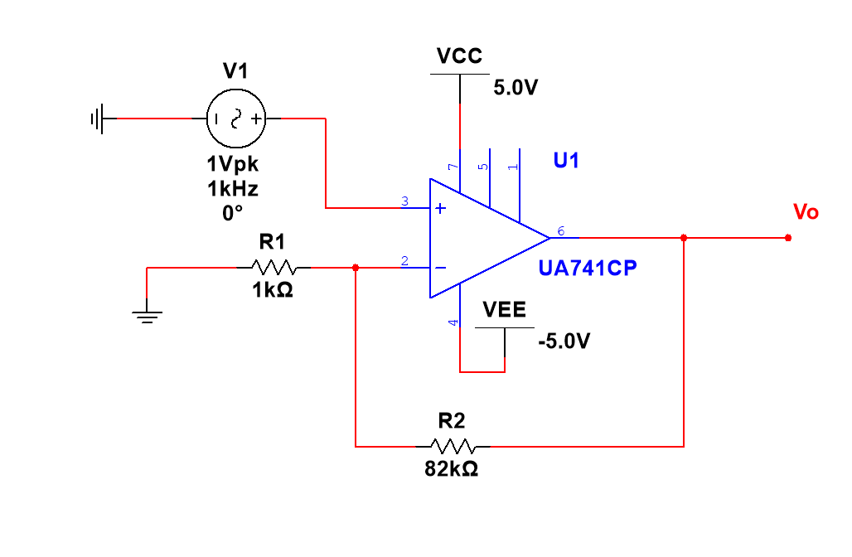

Bode plots: Gain = 23, R2 = 22 kΩ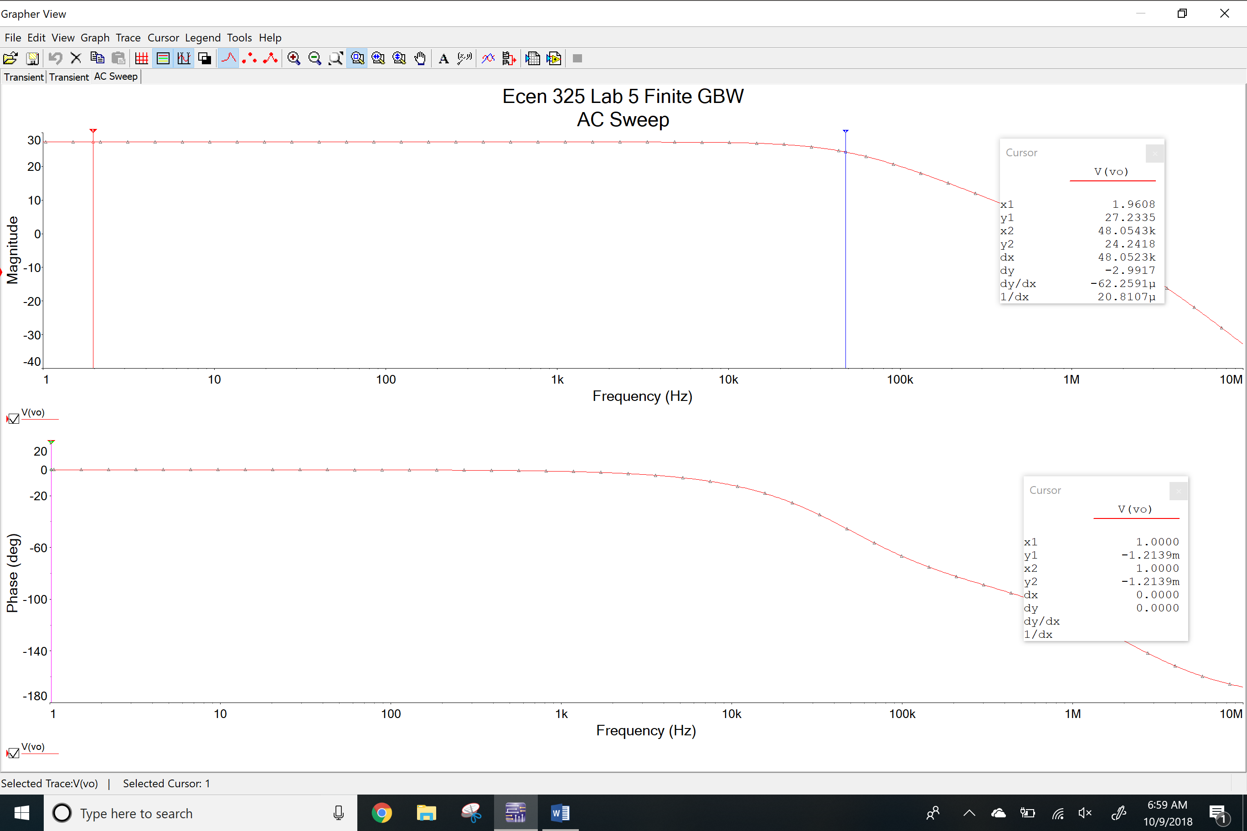

Bode plots: Gain = 57, R2 = 56 kΩ

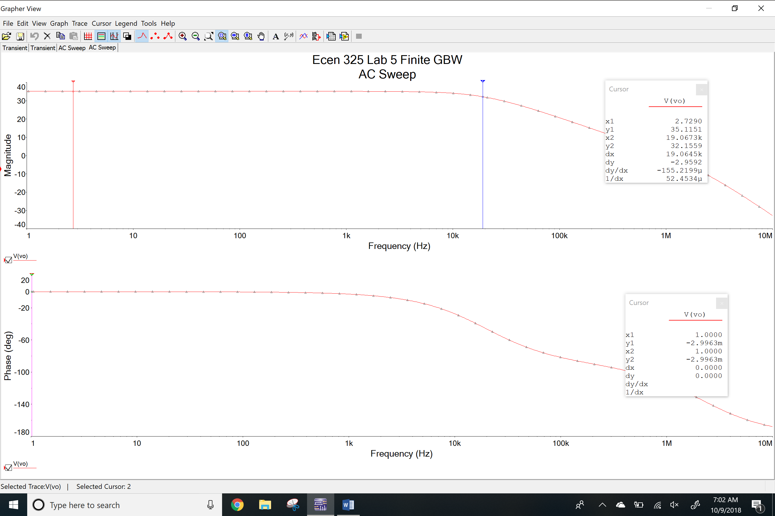

Bode plots: Gain = 83, R2 = 82 kΩ

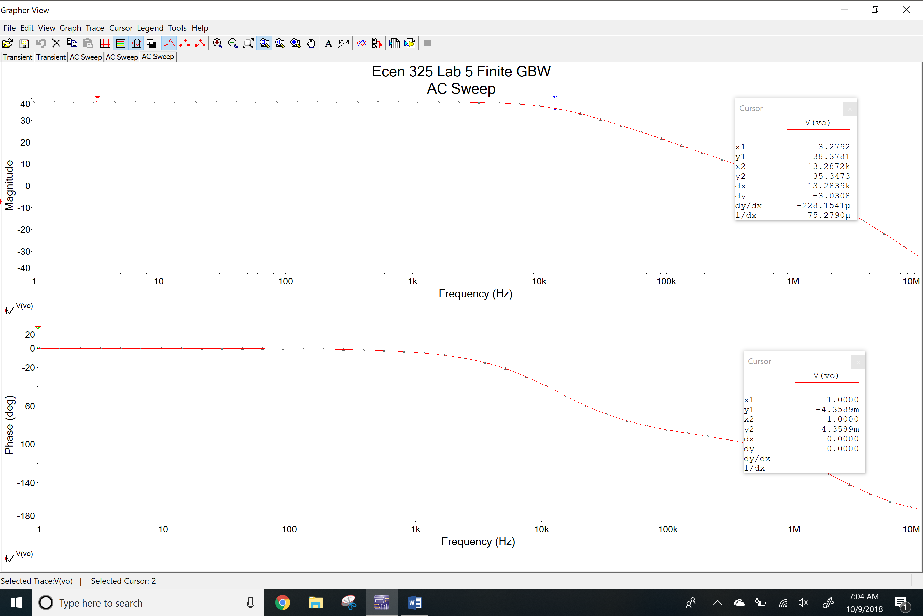

**Slew Rate Limitation**

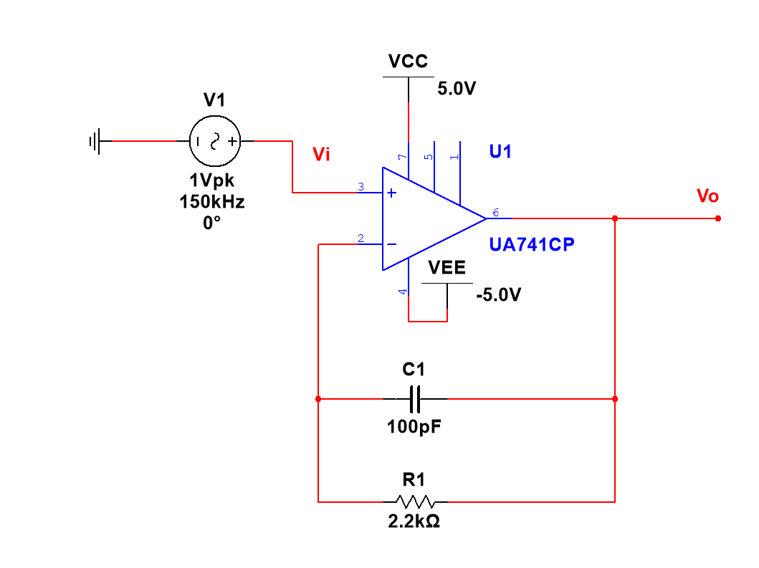

Bode plots

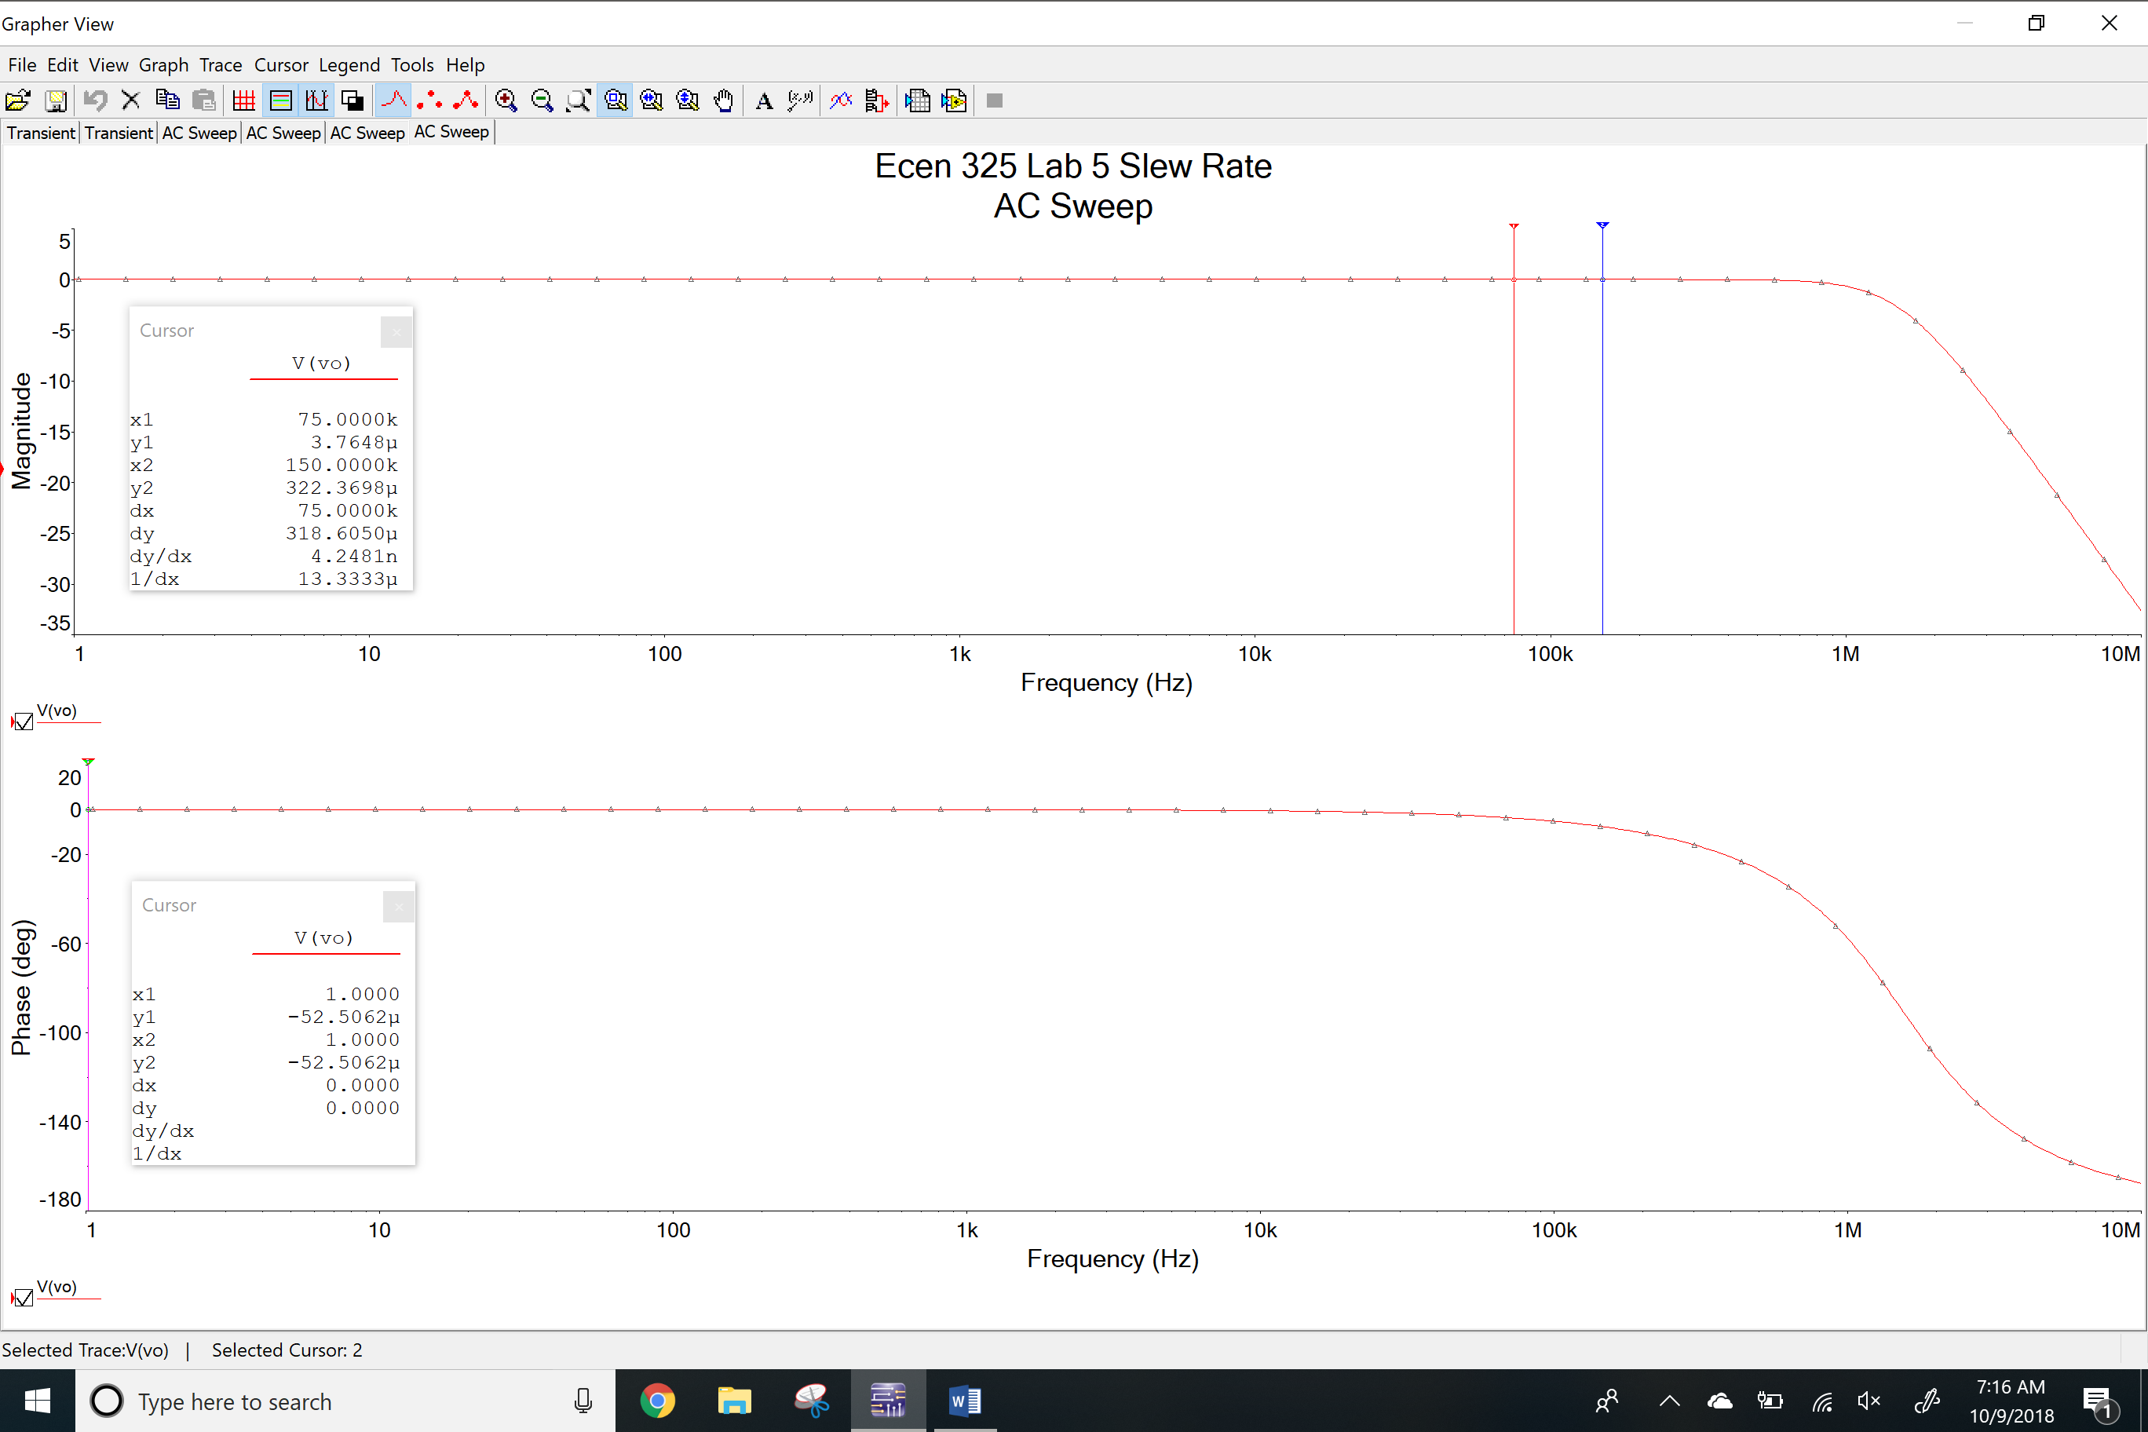

Time-domain waveform: 75 kHz, 1 V

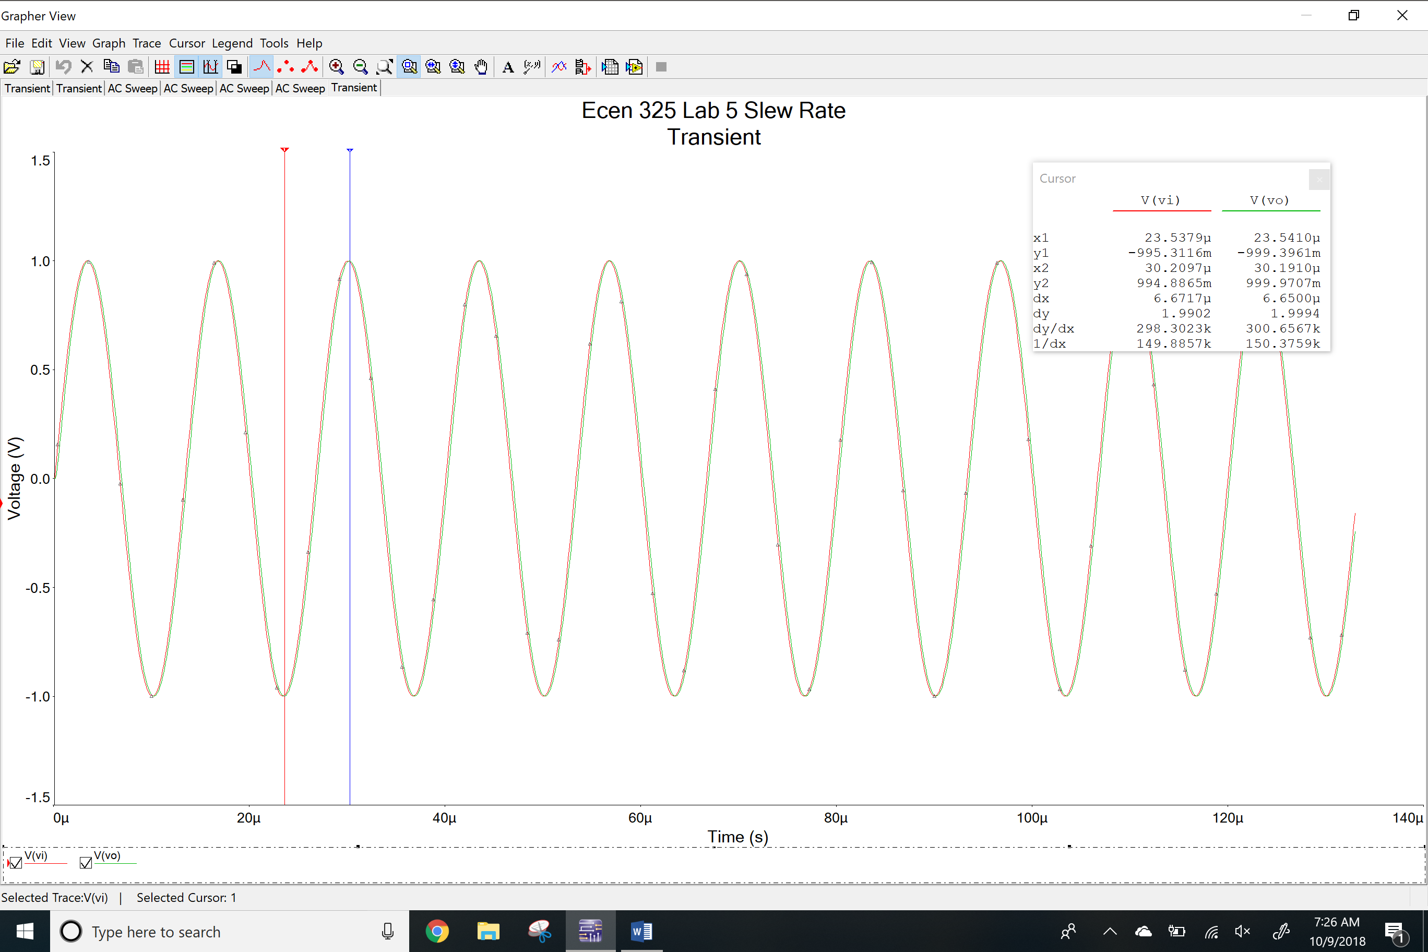

Fourier simulation: 75 kHz, 1 V

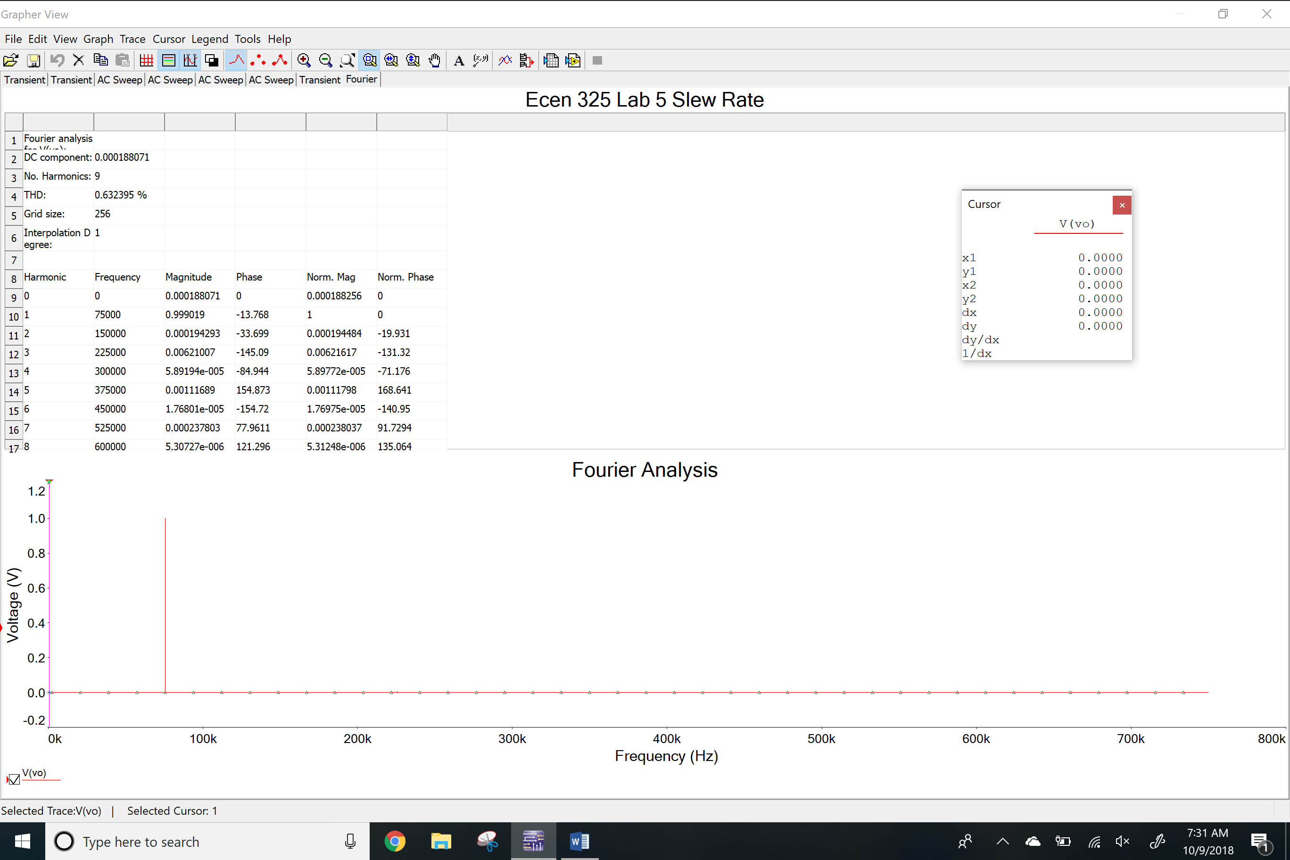

Time-domain waveform: 75 kHz, 2 V

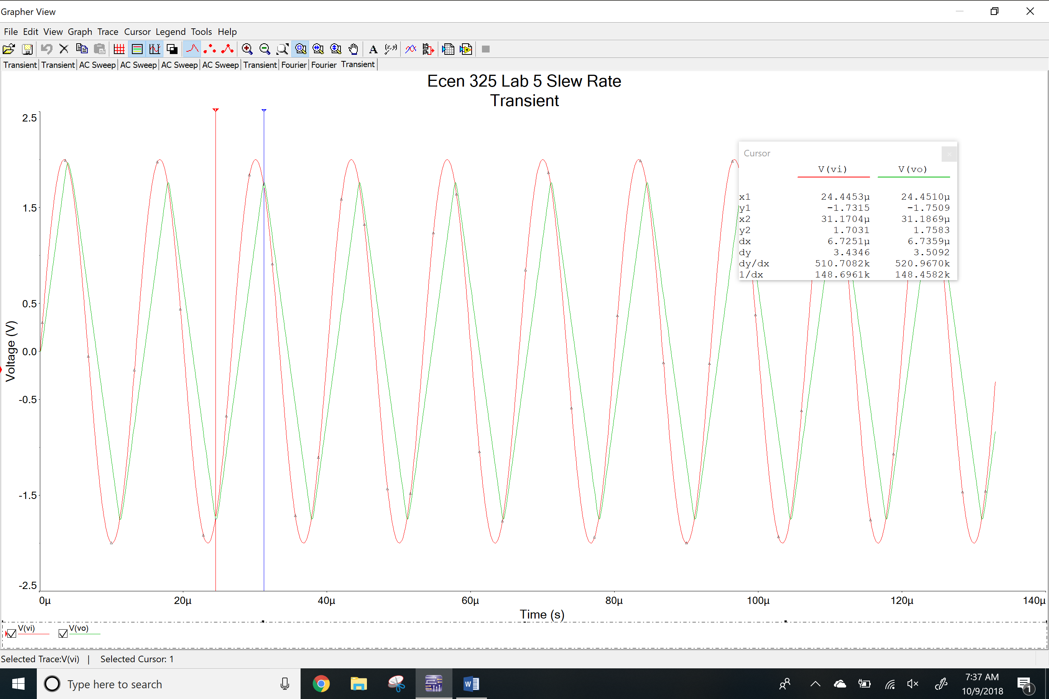

Fourier simulation: 75 kHz, 2 V

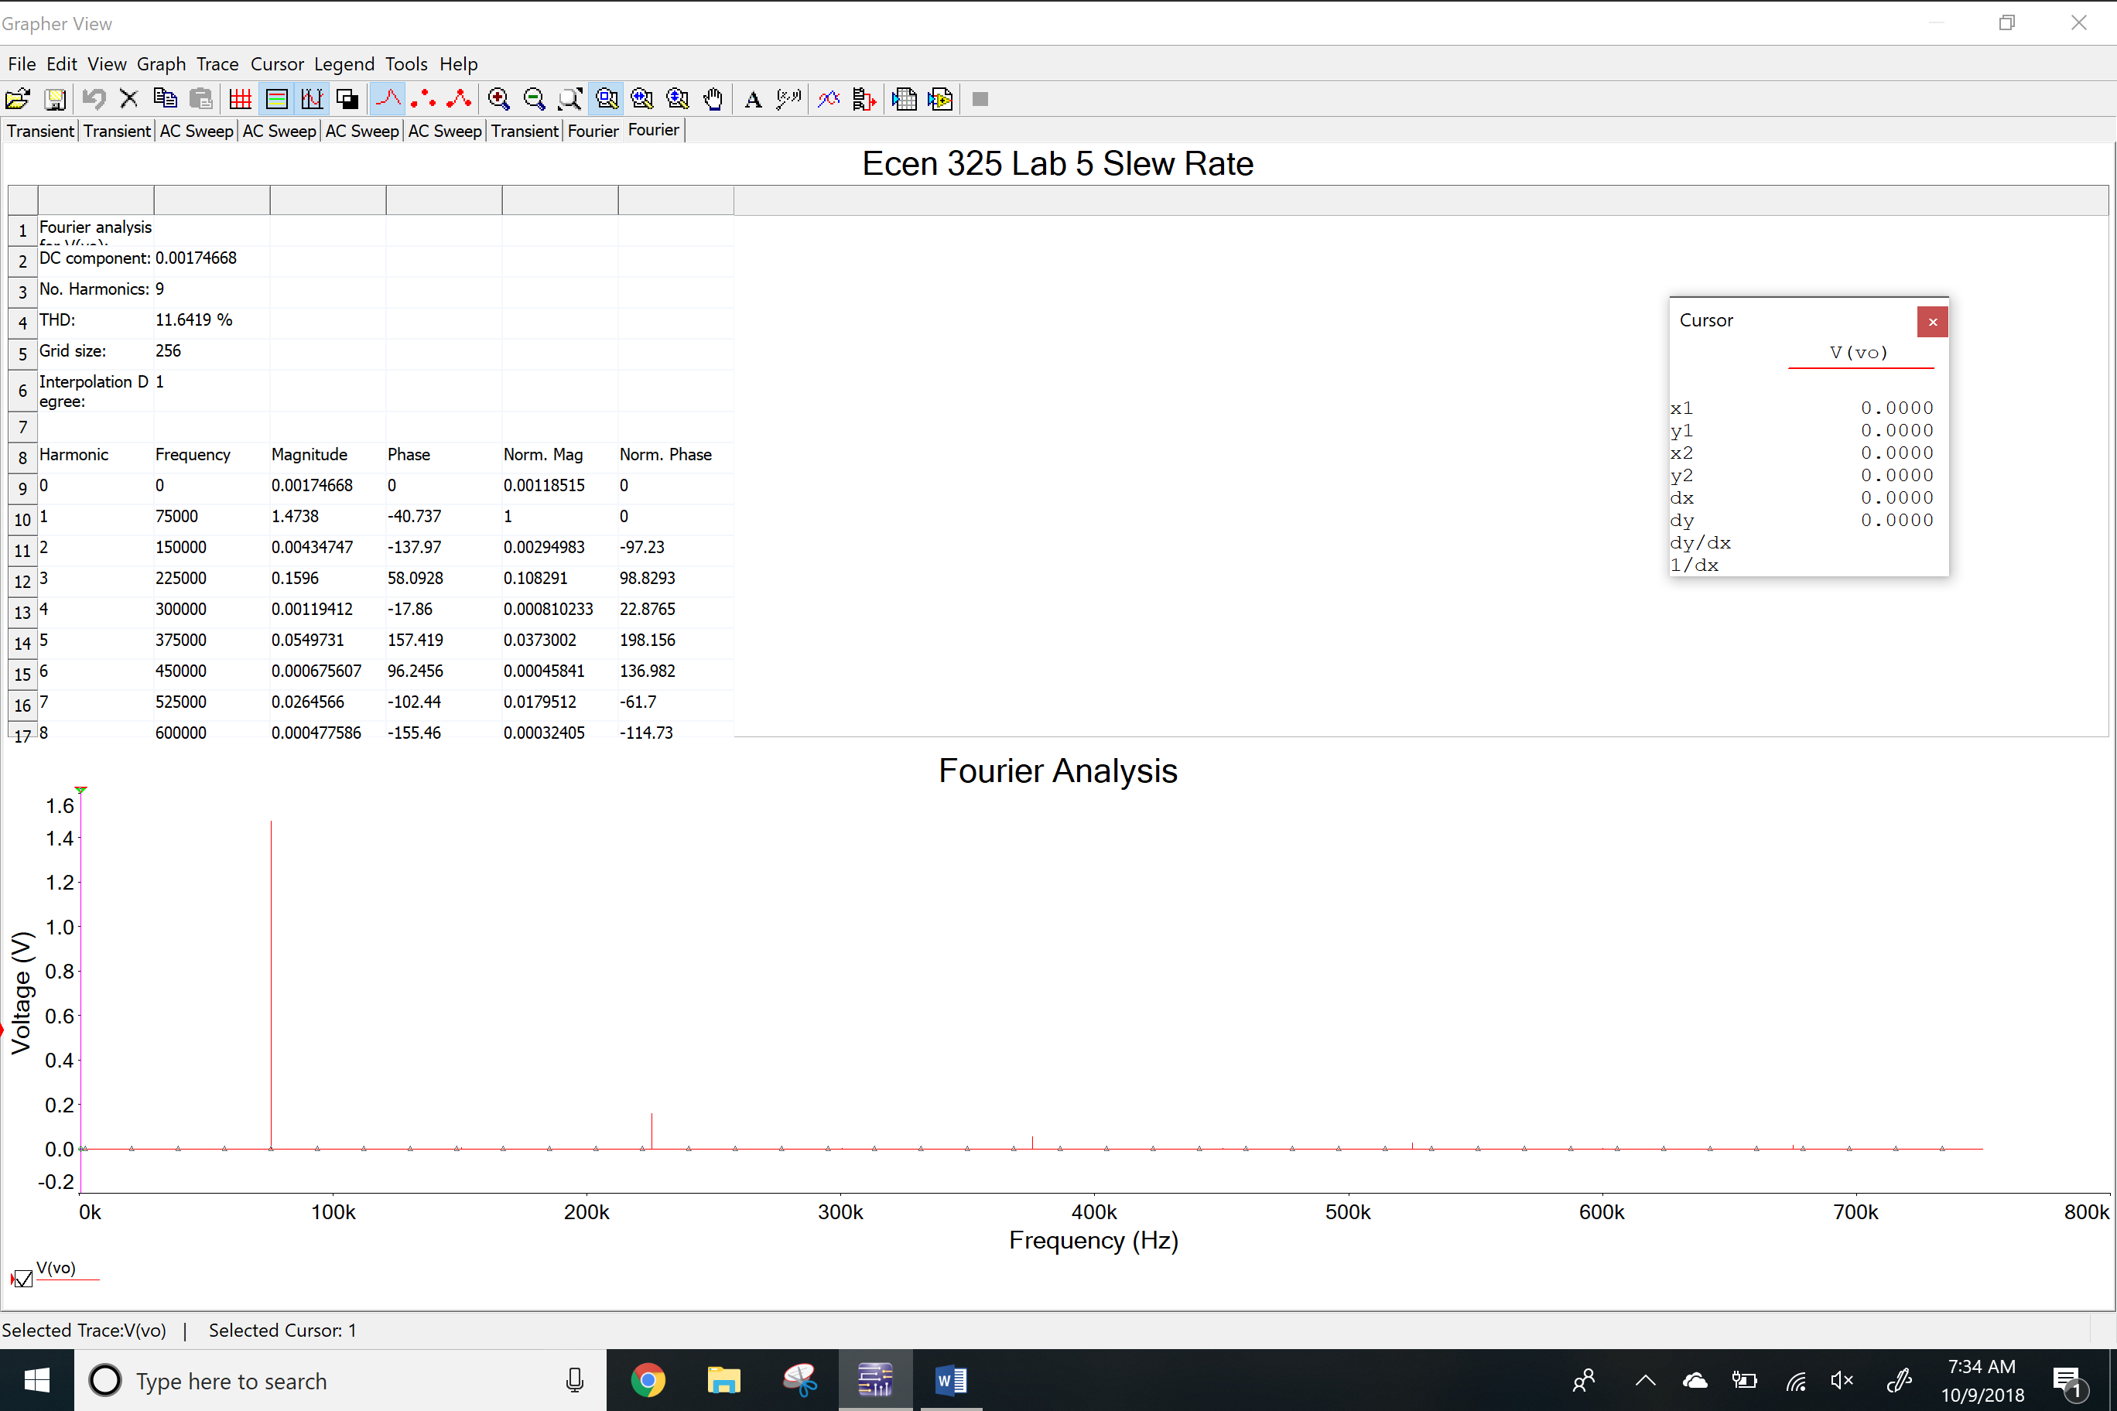

Time-domain waveform: 150 kHz, 1 V

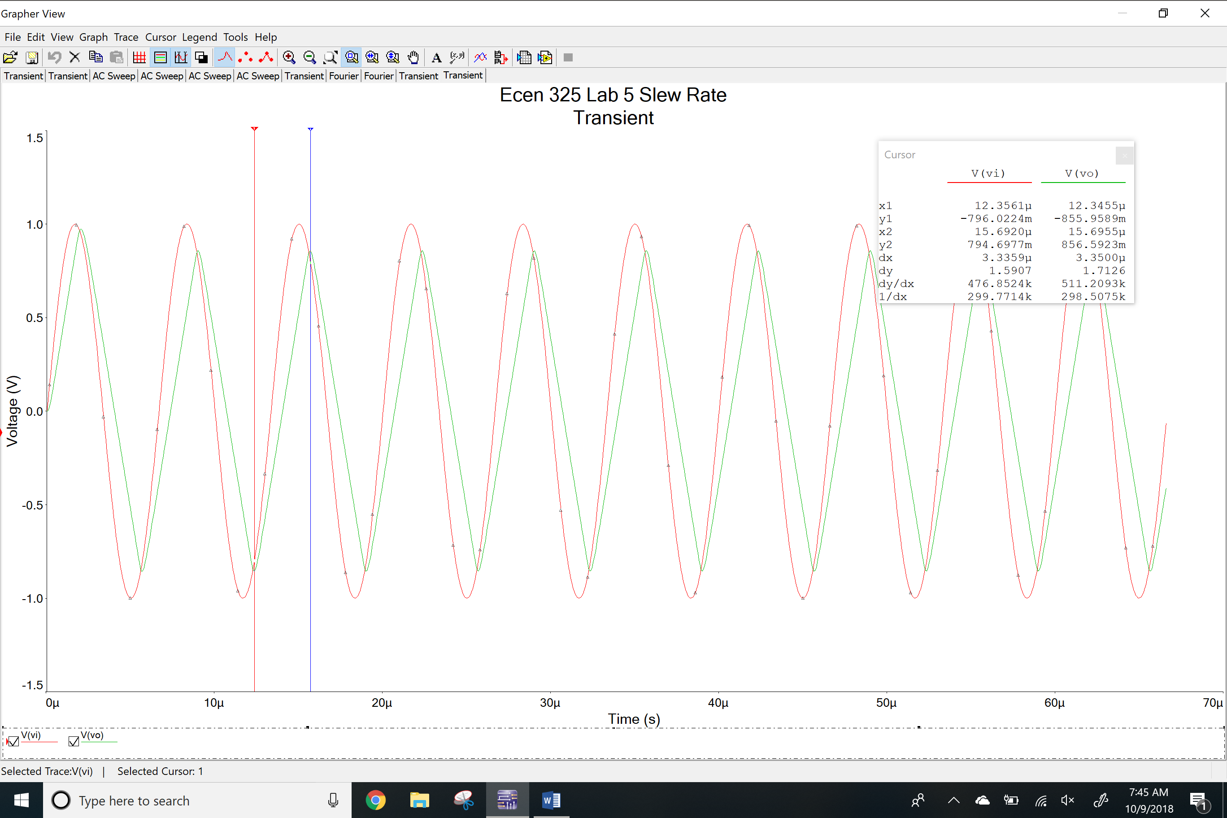

Fourier simulation: 150 kHz, 1 V

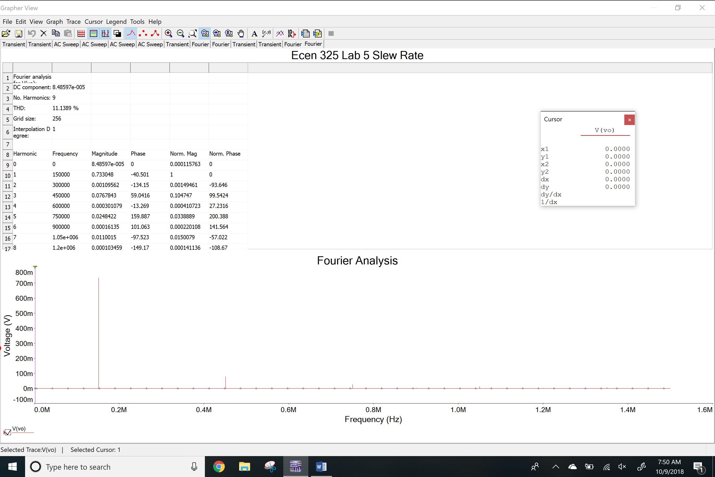

**Measurements**

**Integrator**

Bode plots

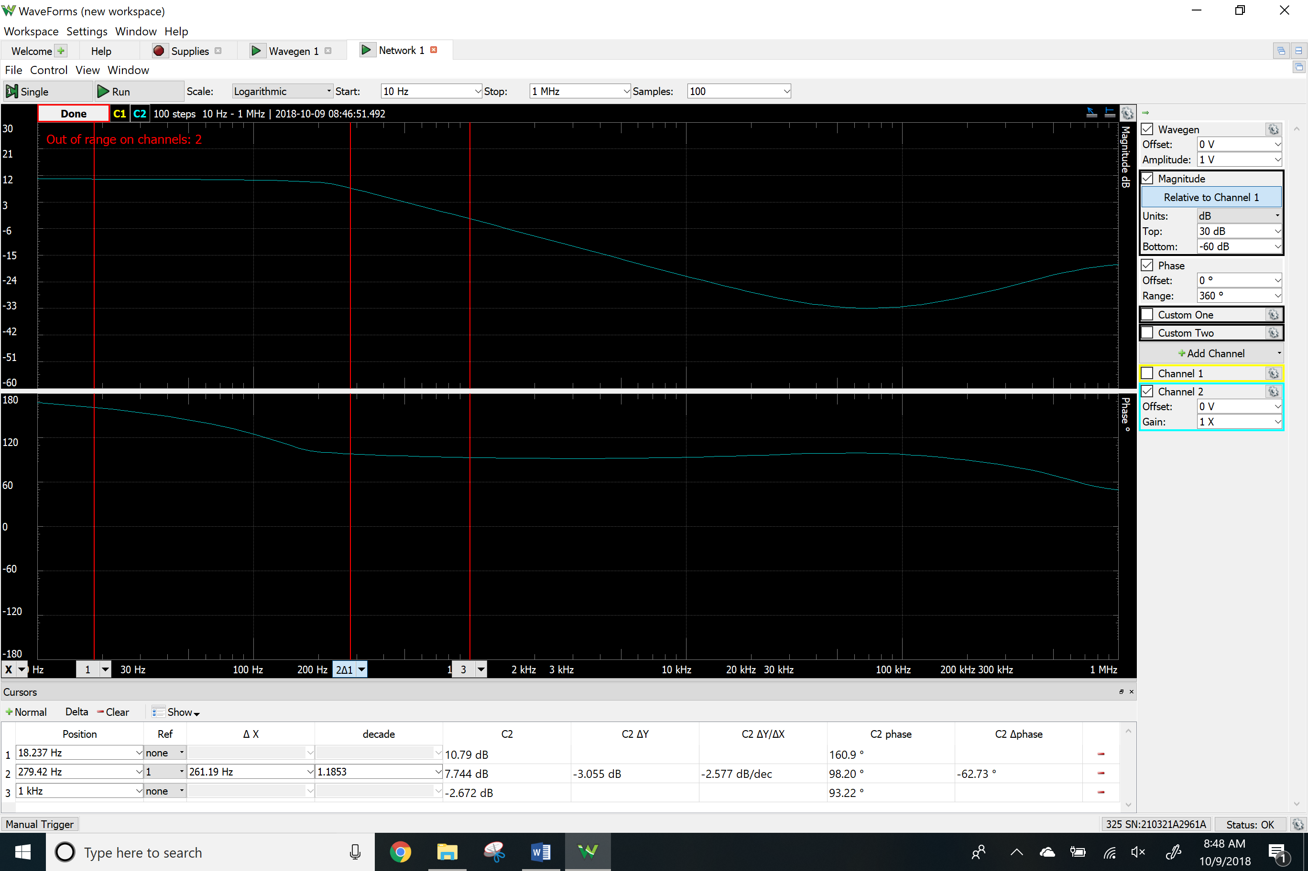

Time-domain waveform: 1 kHz, 500 mV, sine wave

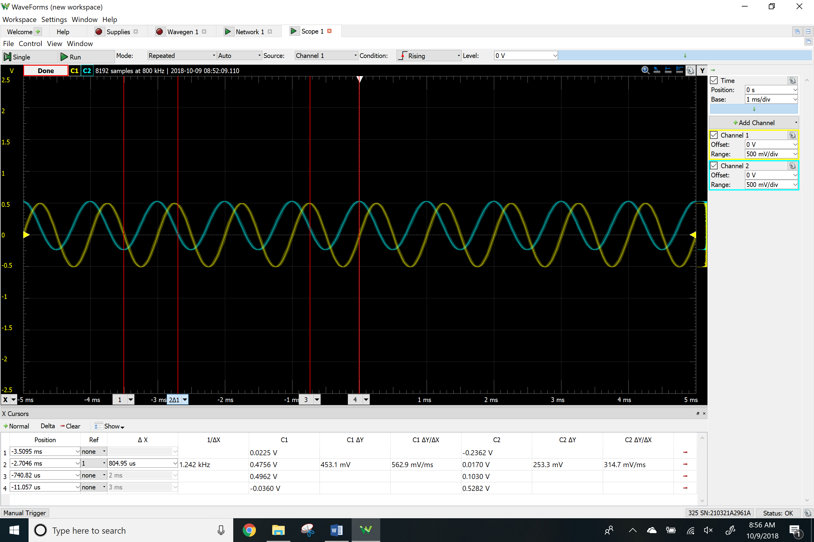

Time-domain waveform: 1 kHz, 500 mV, square wave

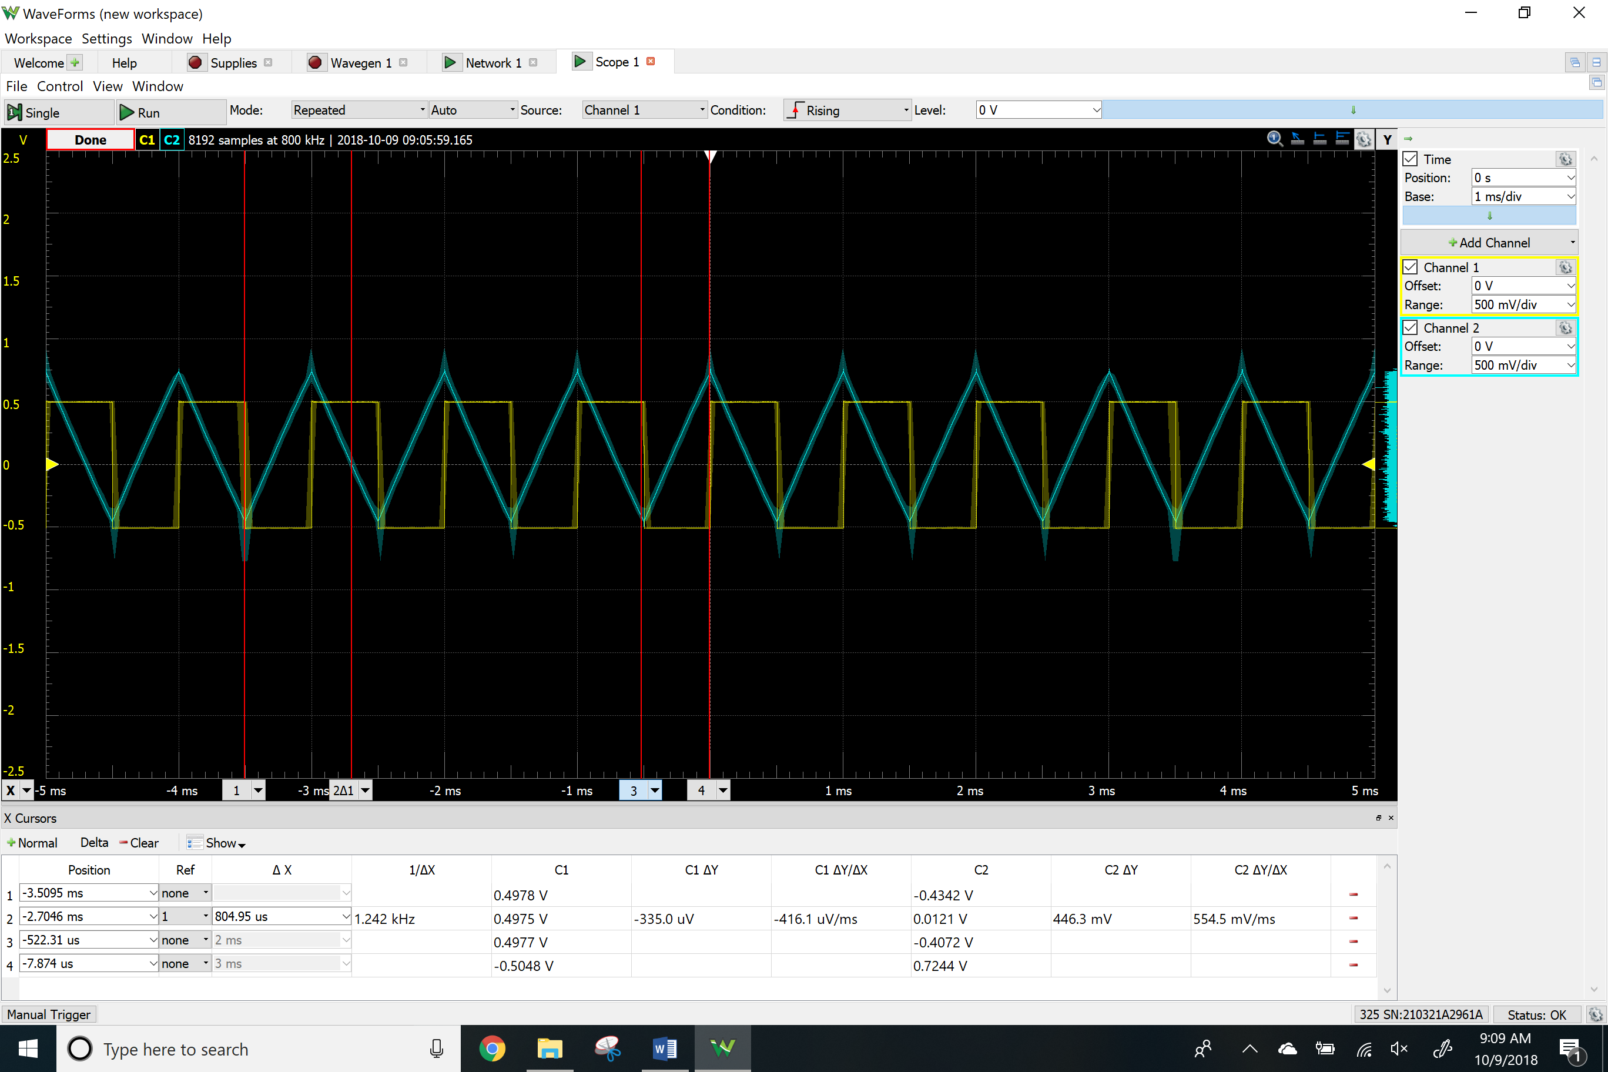

Time-domain waveform: without R2

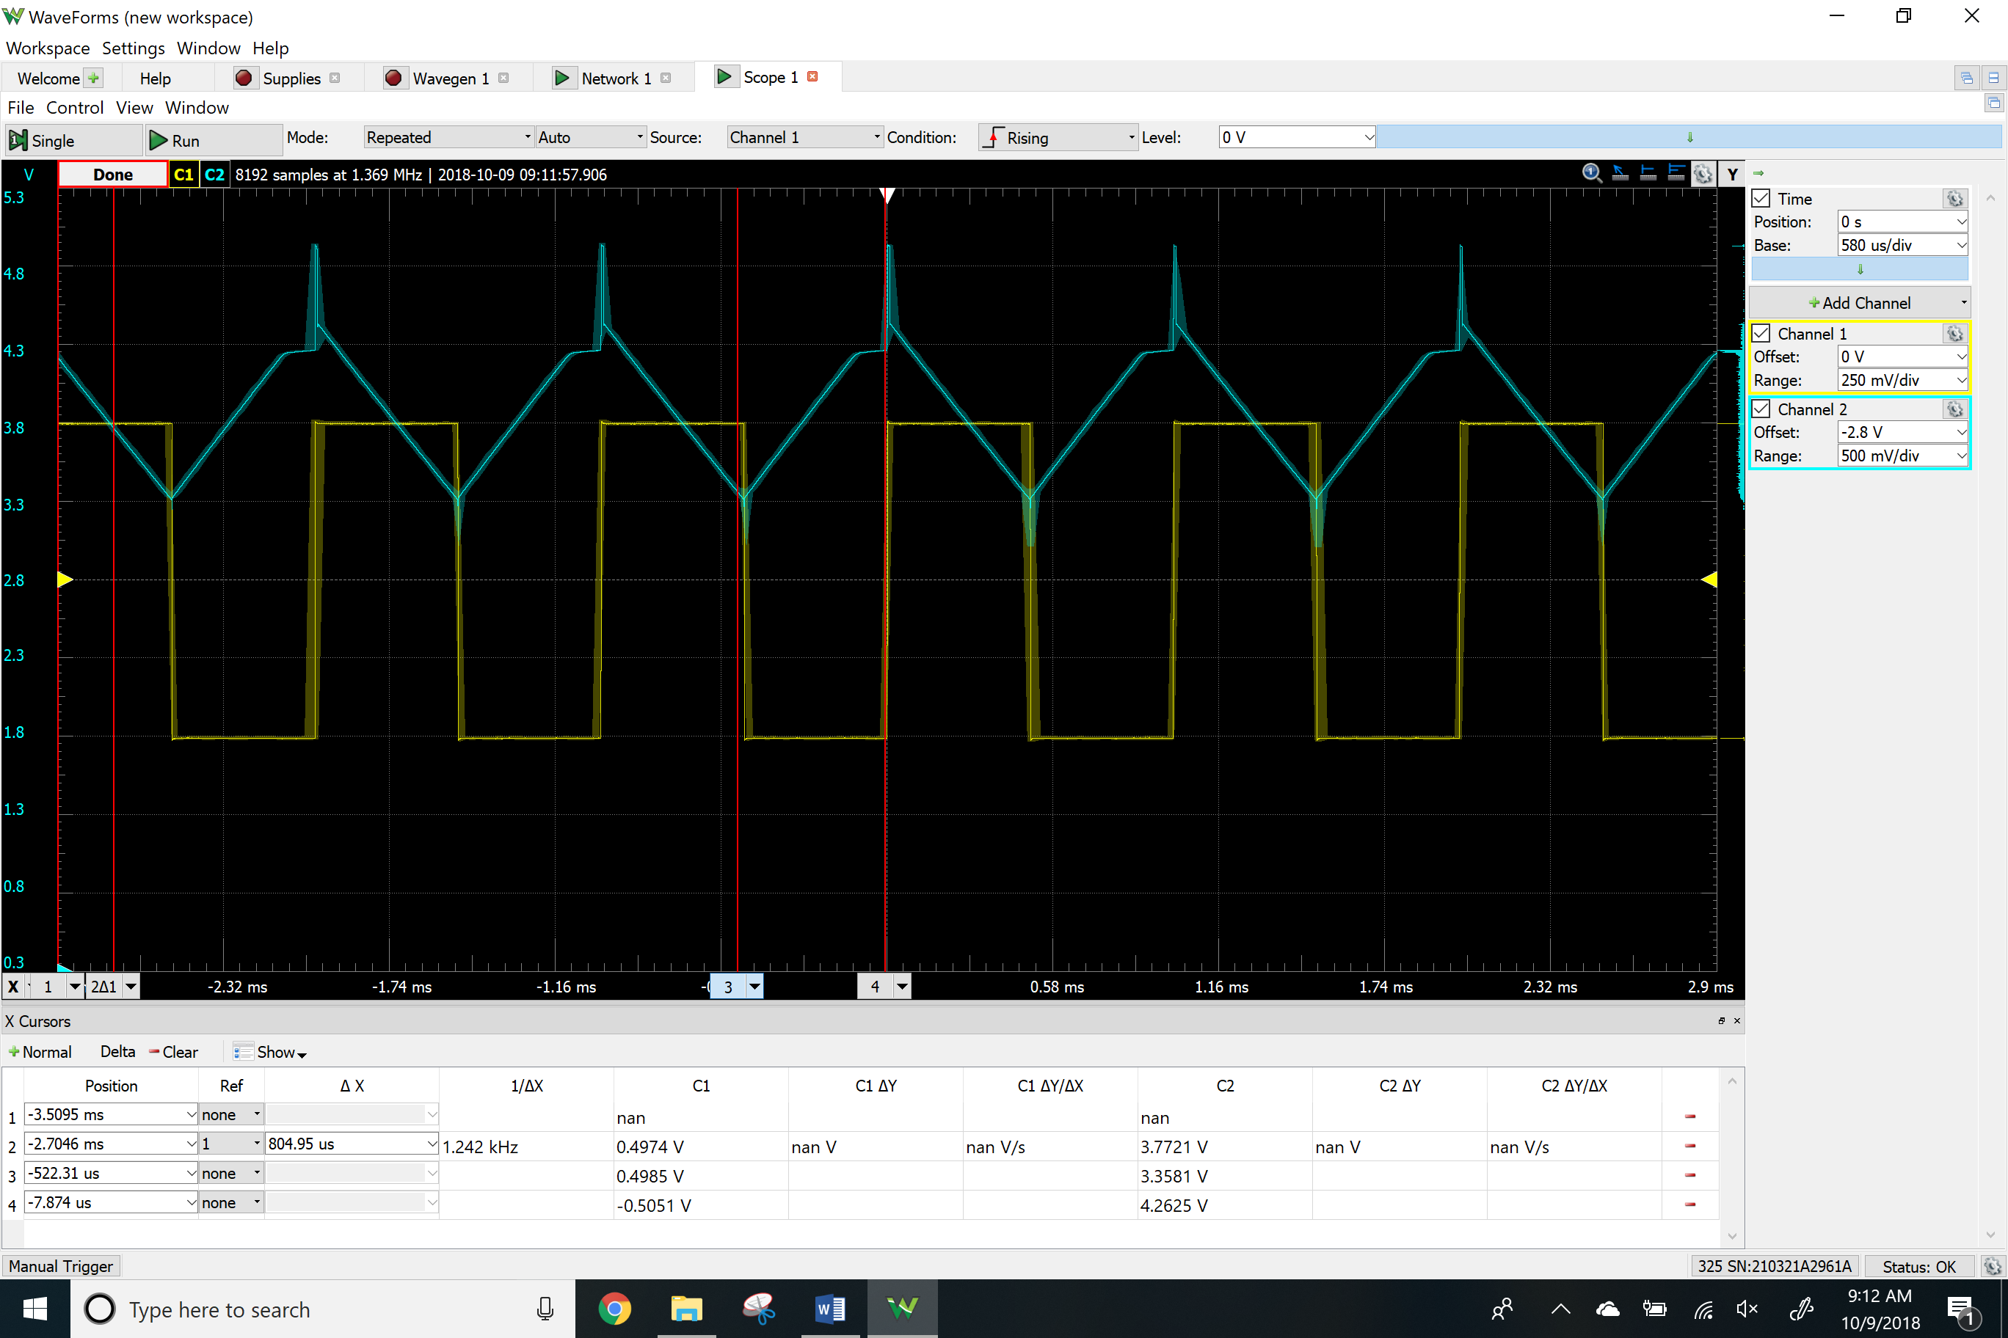

**Differentiator**

Bode plots

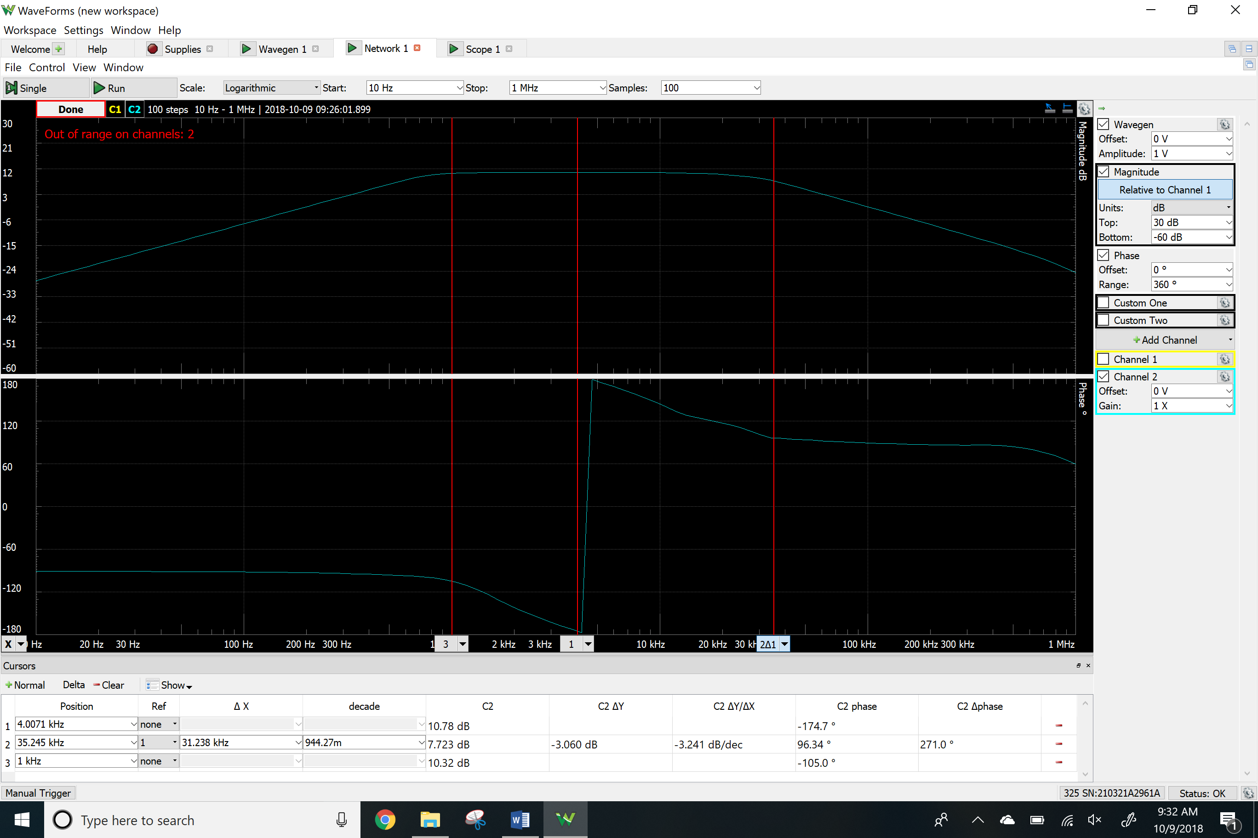

Time-domain waveform: 1 kHz, 100 mV, sine wave

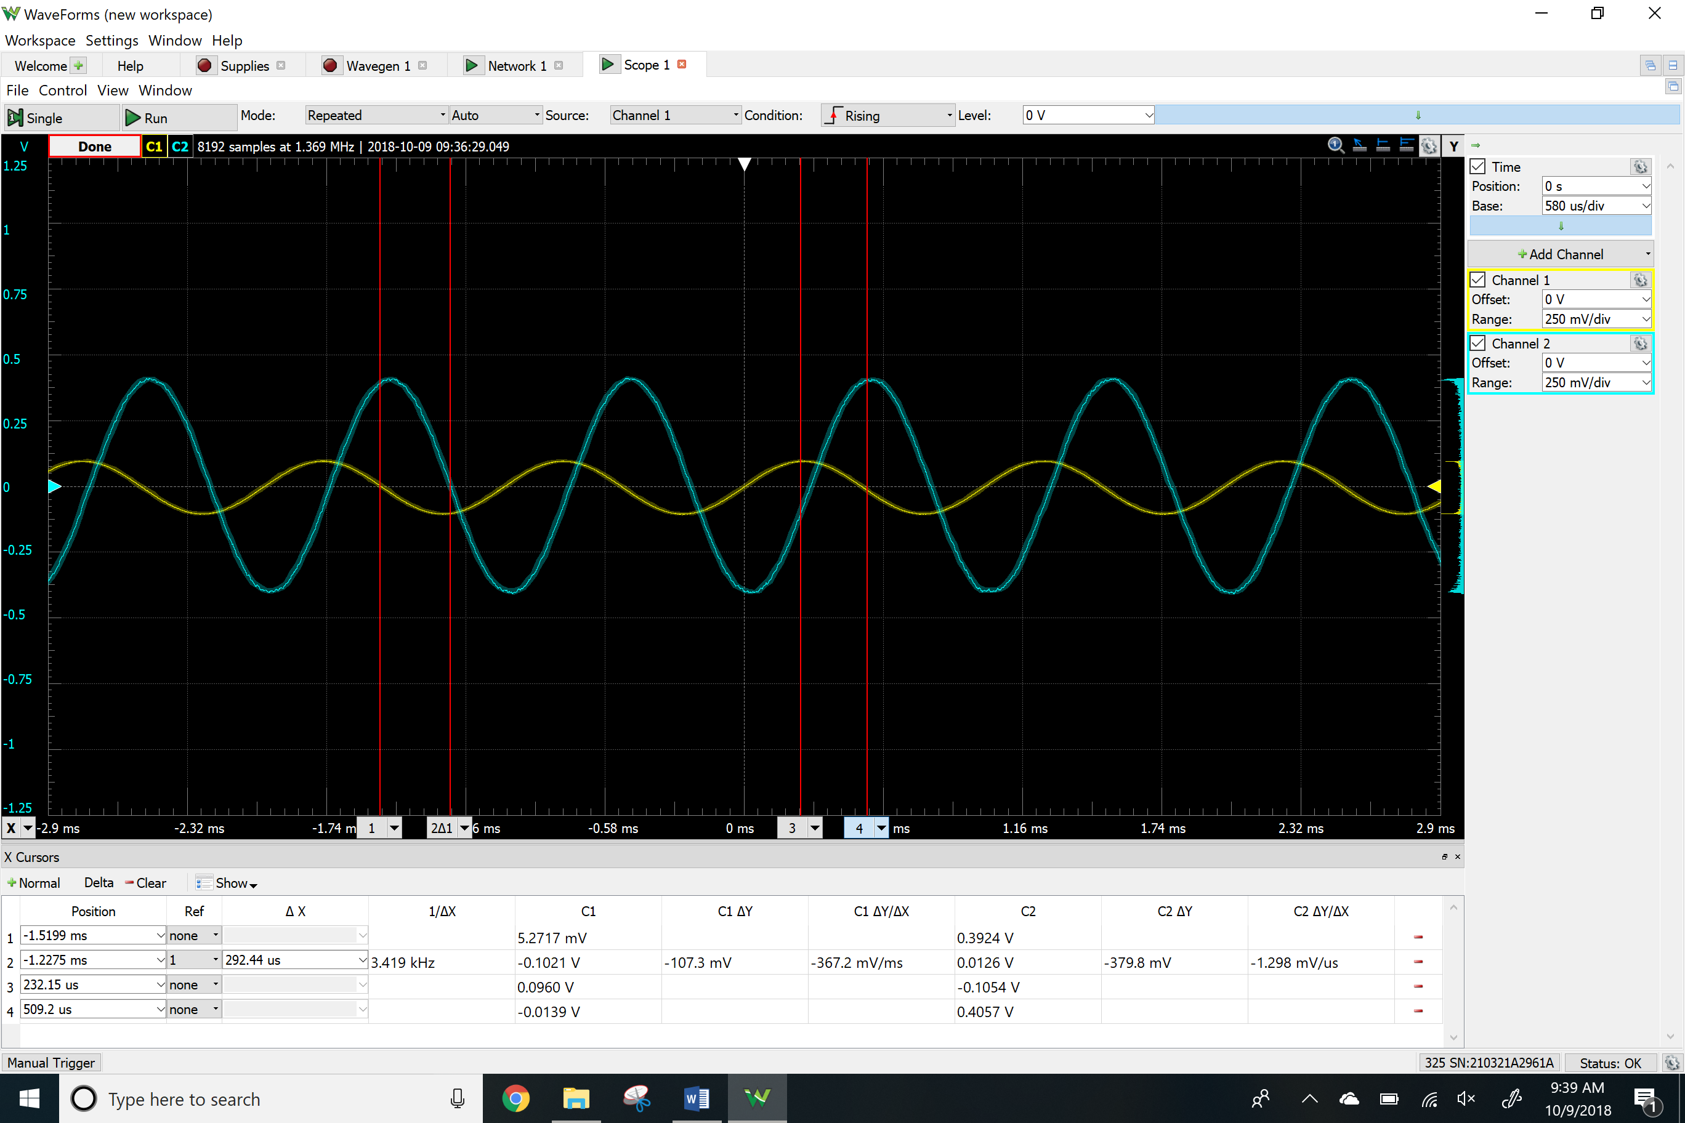

Time-domain waveform: 1 kHz, 100 mV, triangle wave

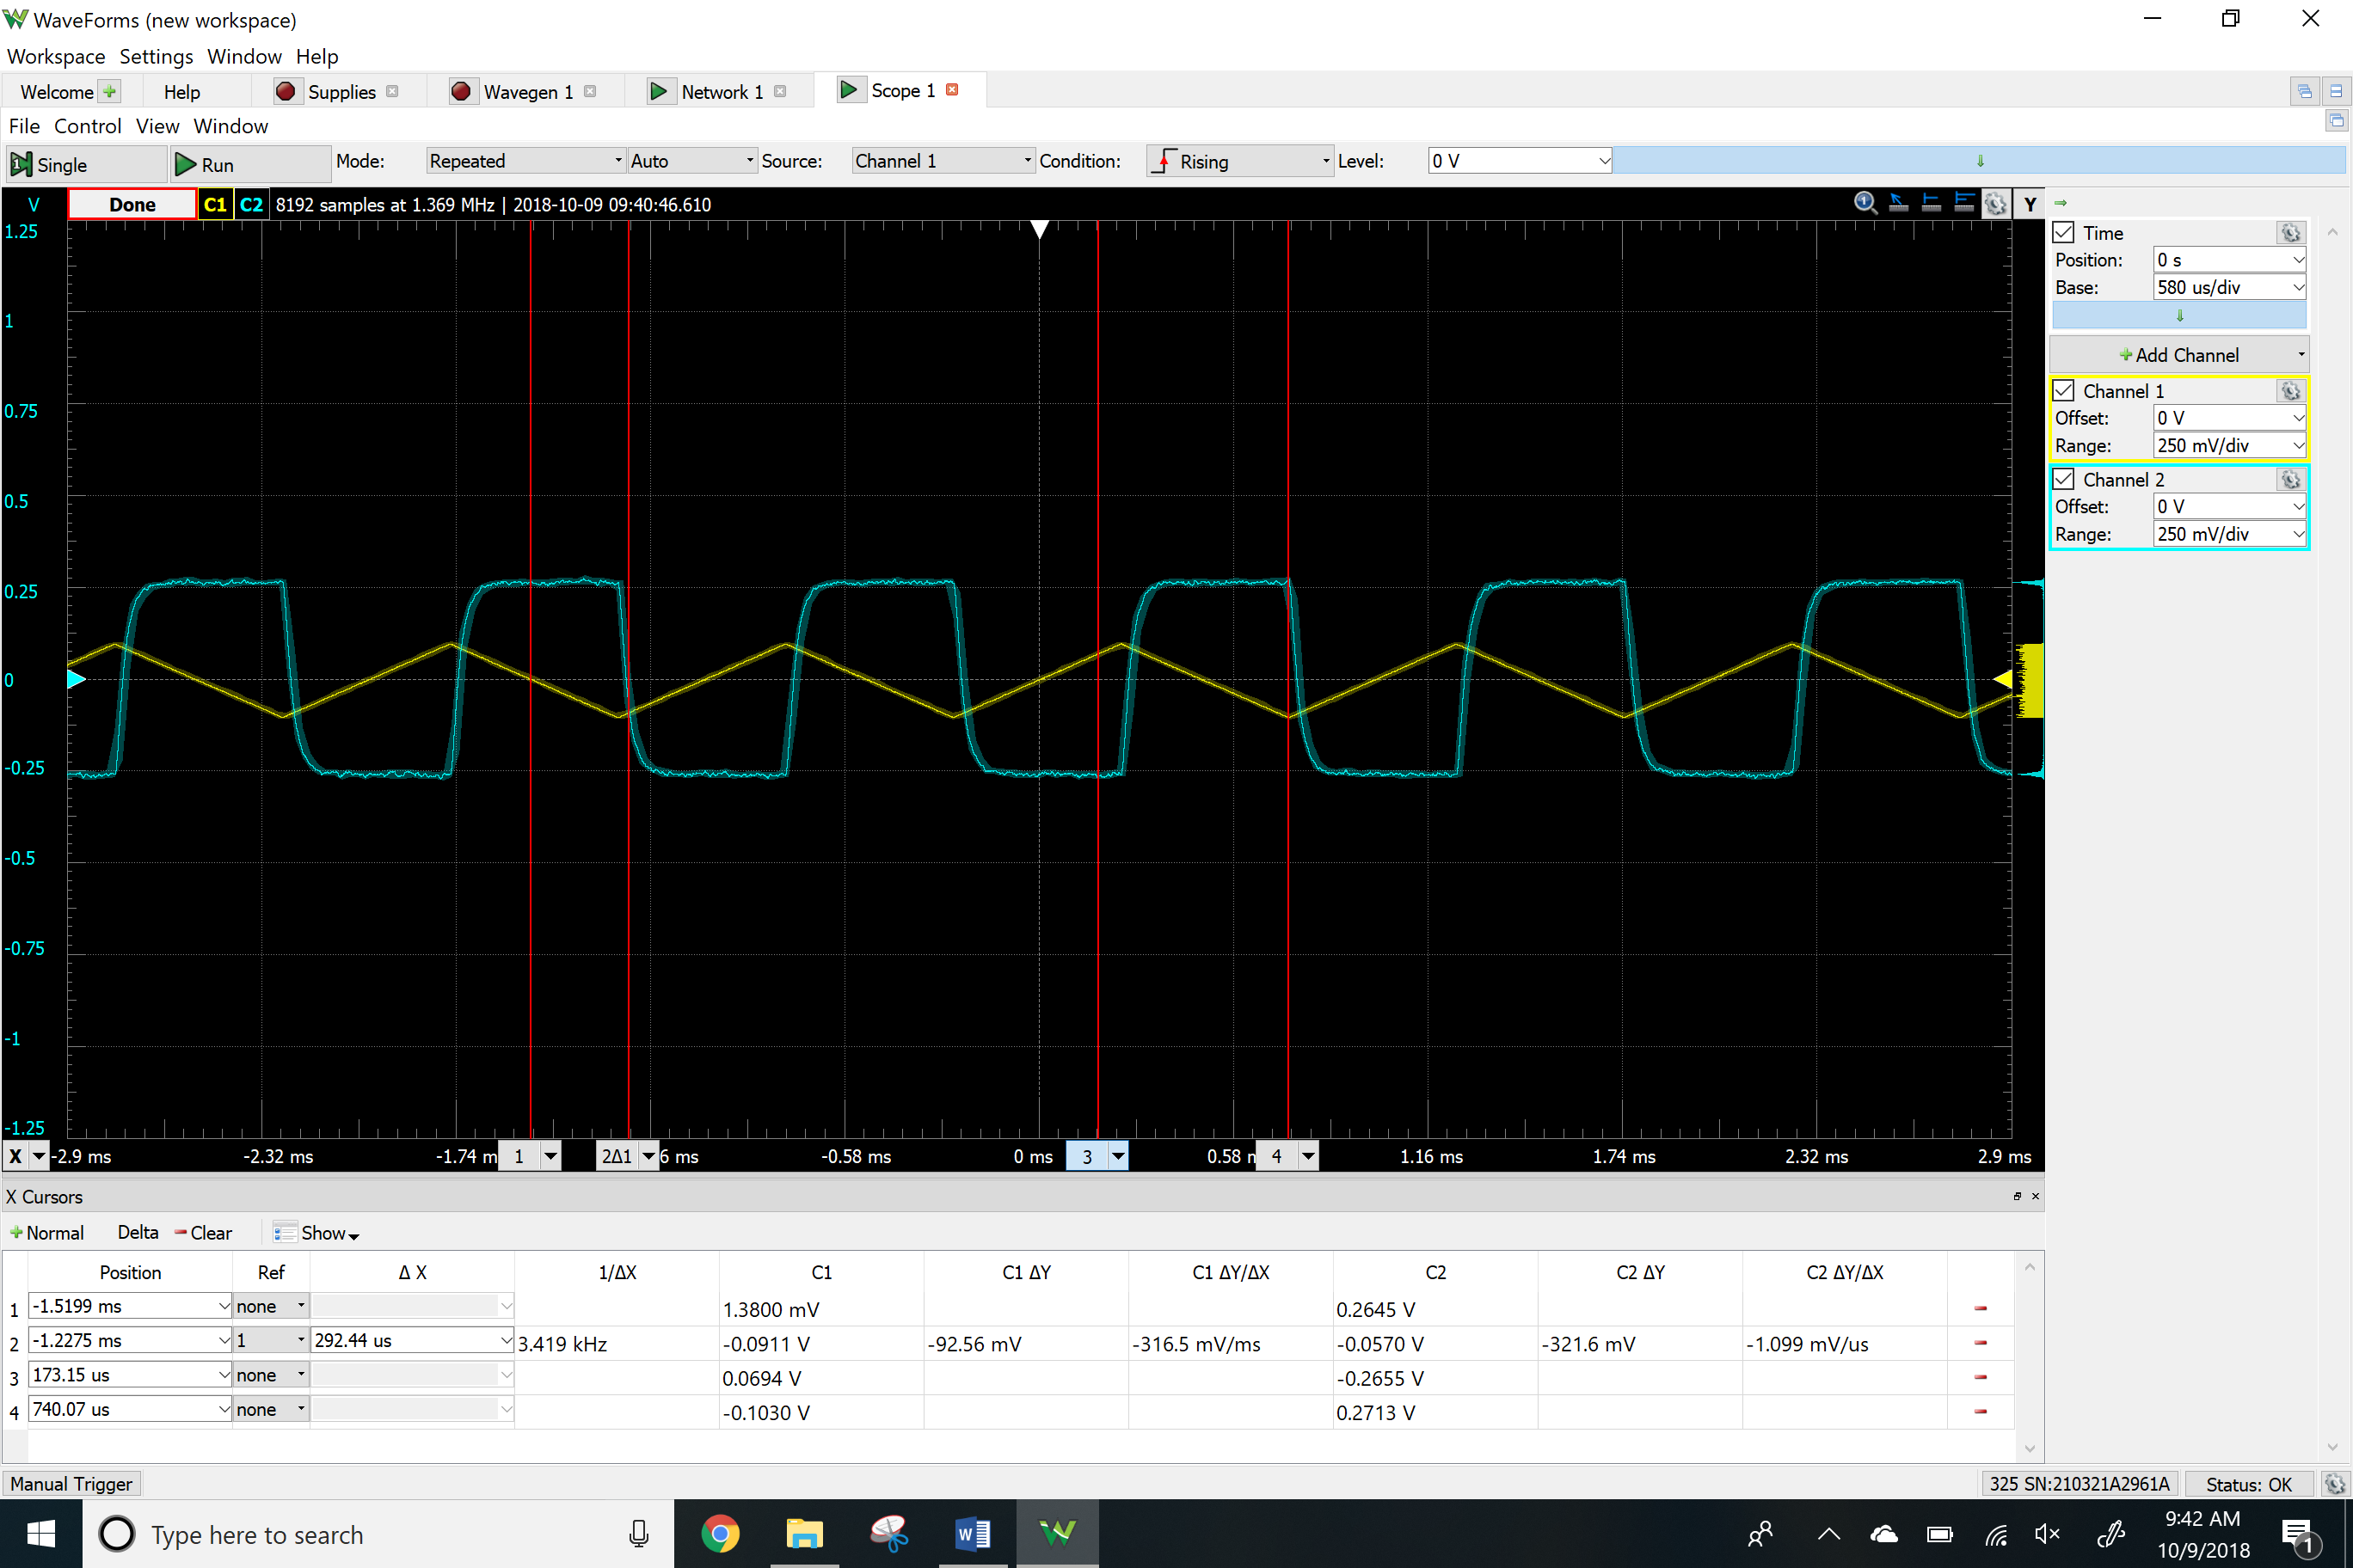

**Finite GBW limitations**

Bode plots, gain = 23

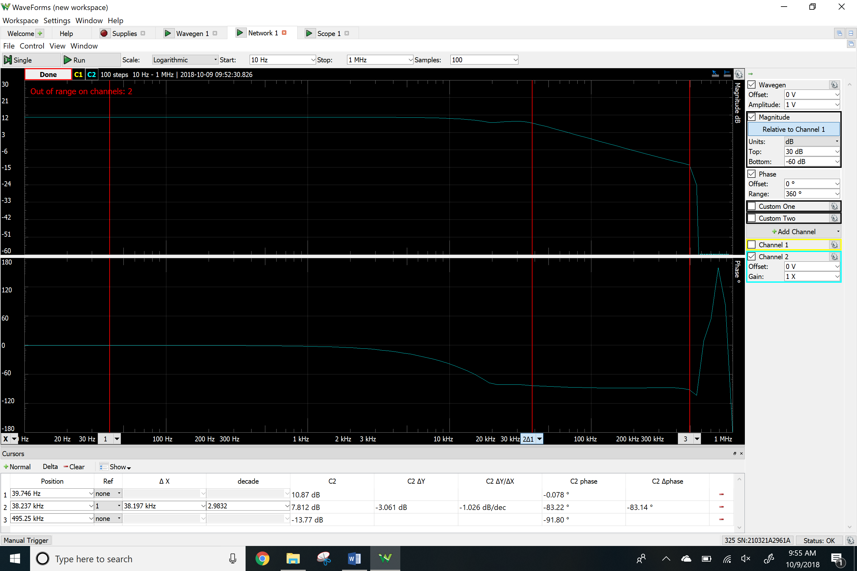

Bode plots, gain = 57

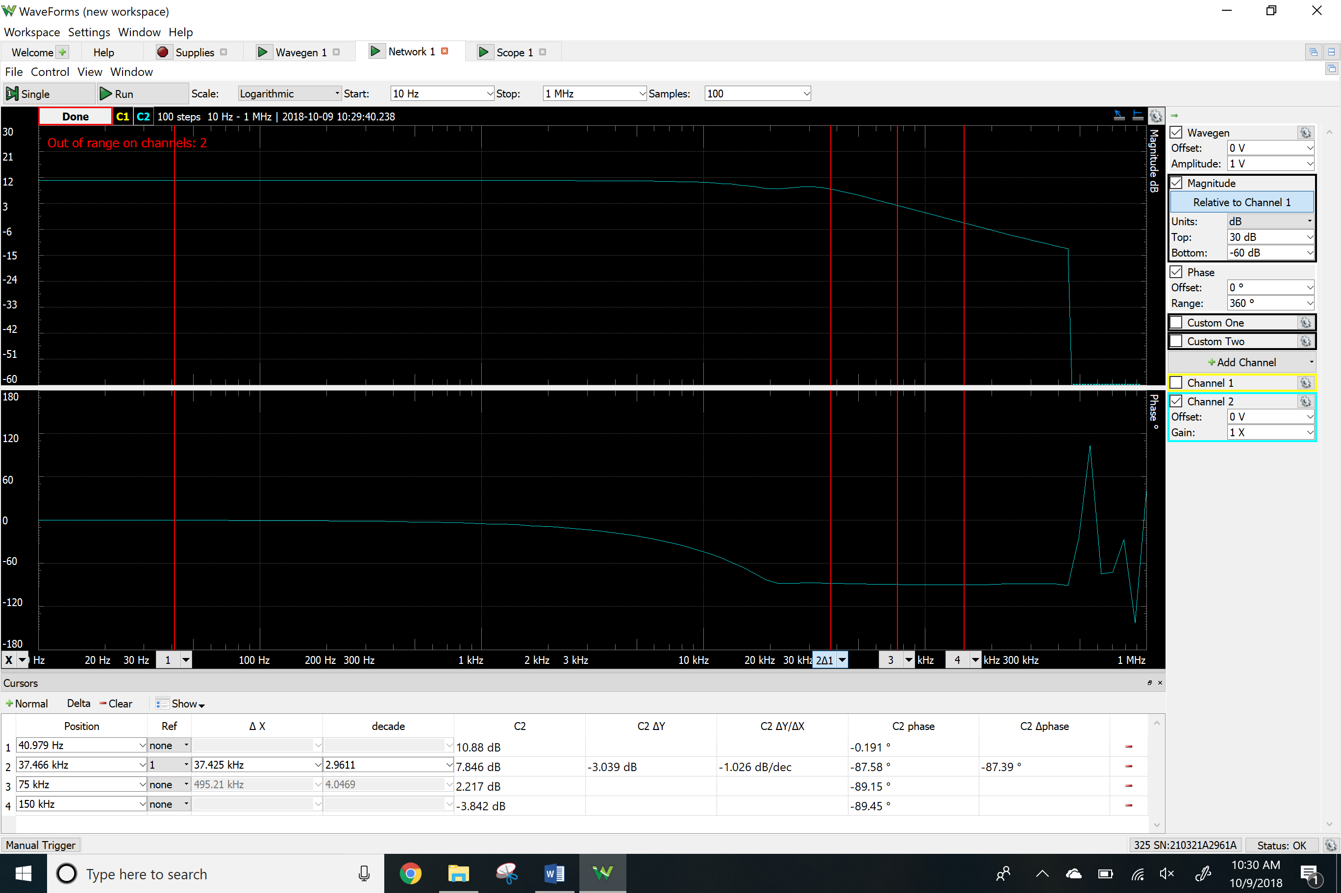

Bode plots, gain = 83

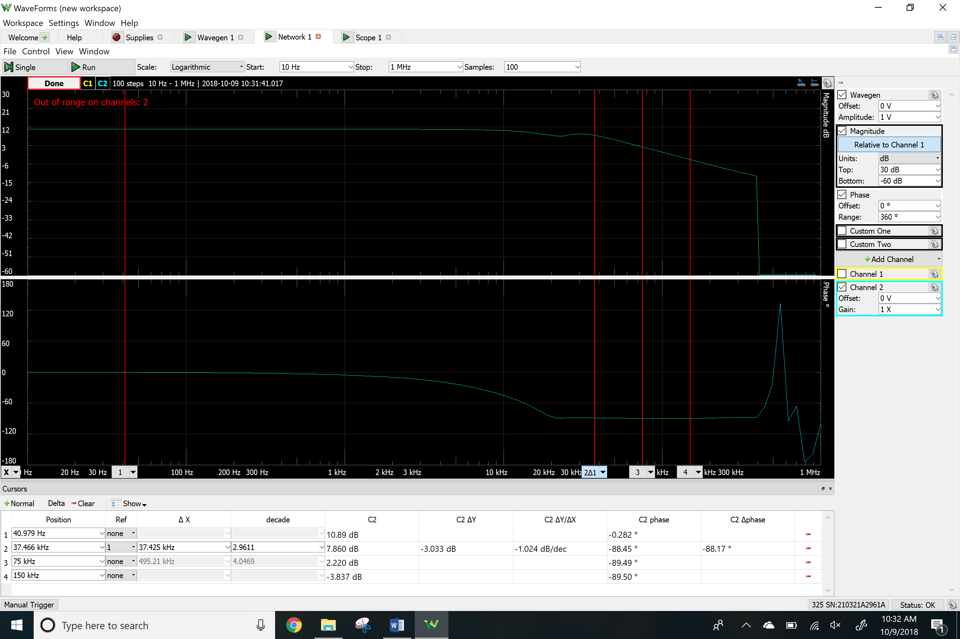

**Slew rate limitation**

Bode plots

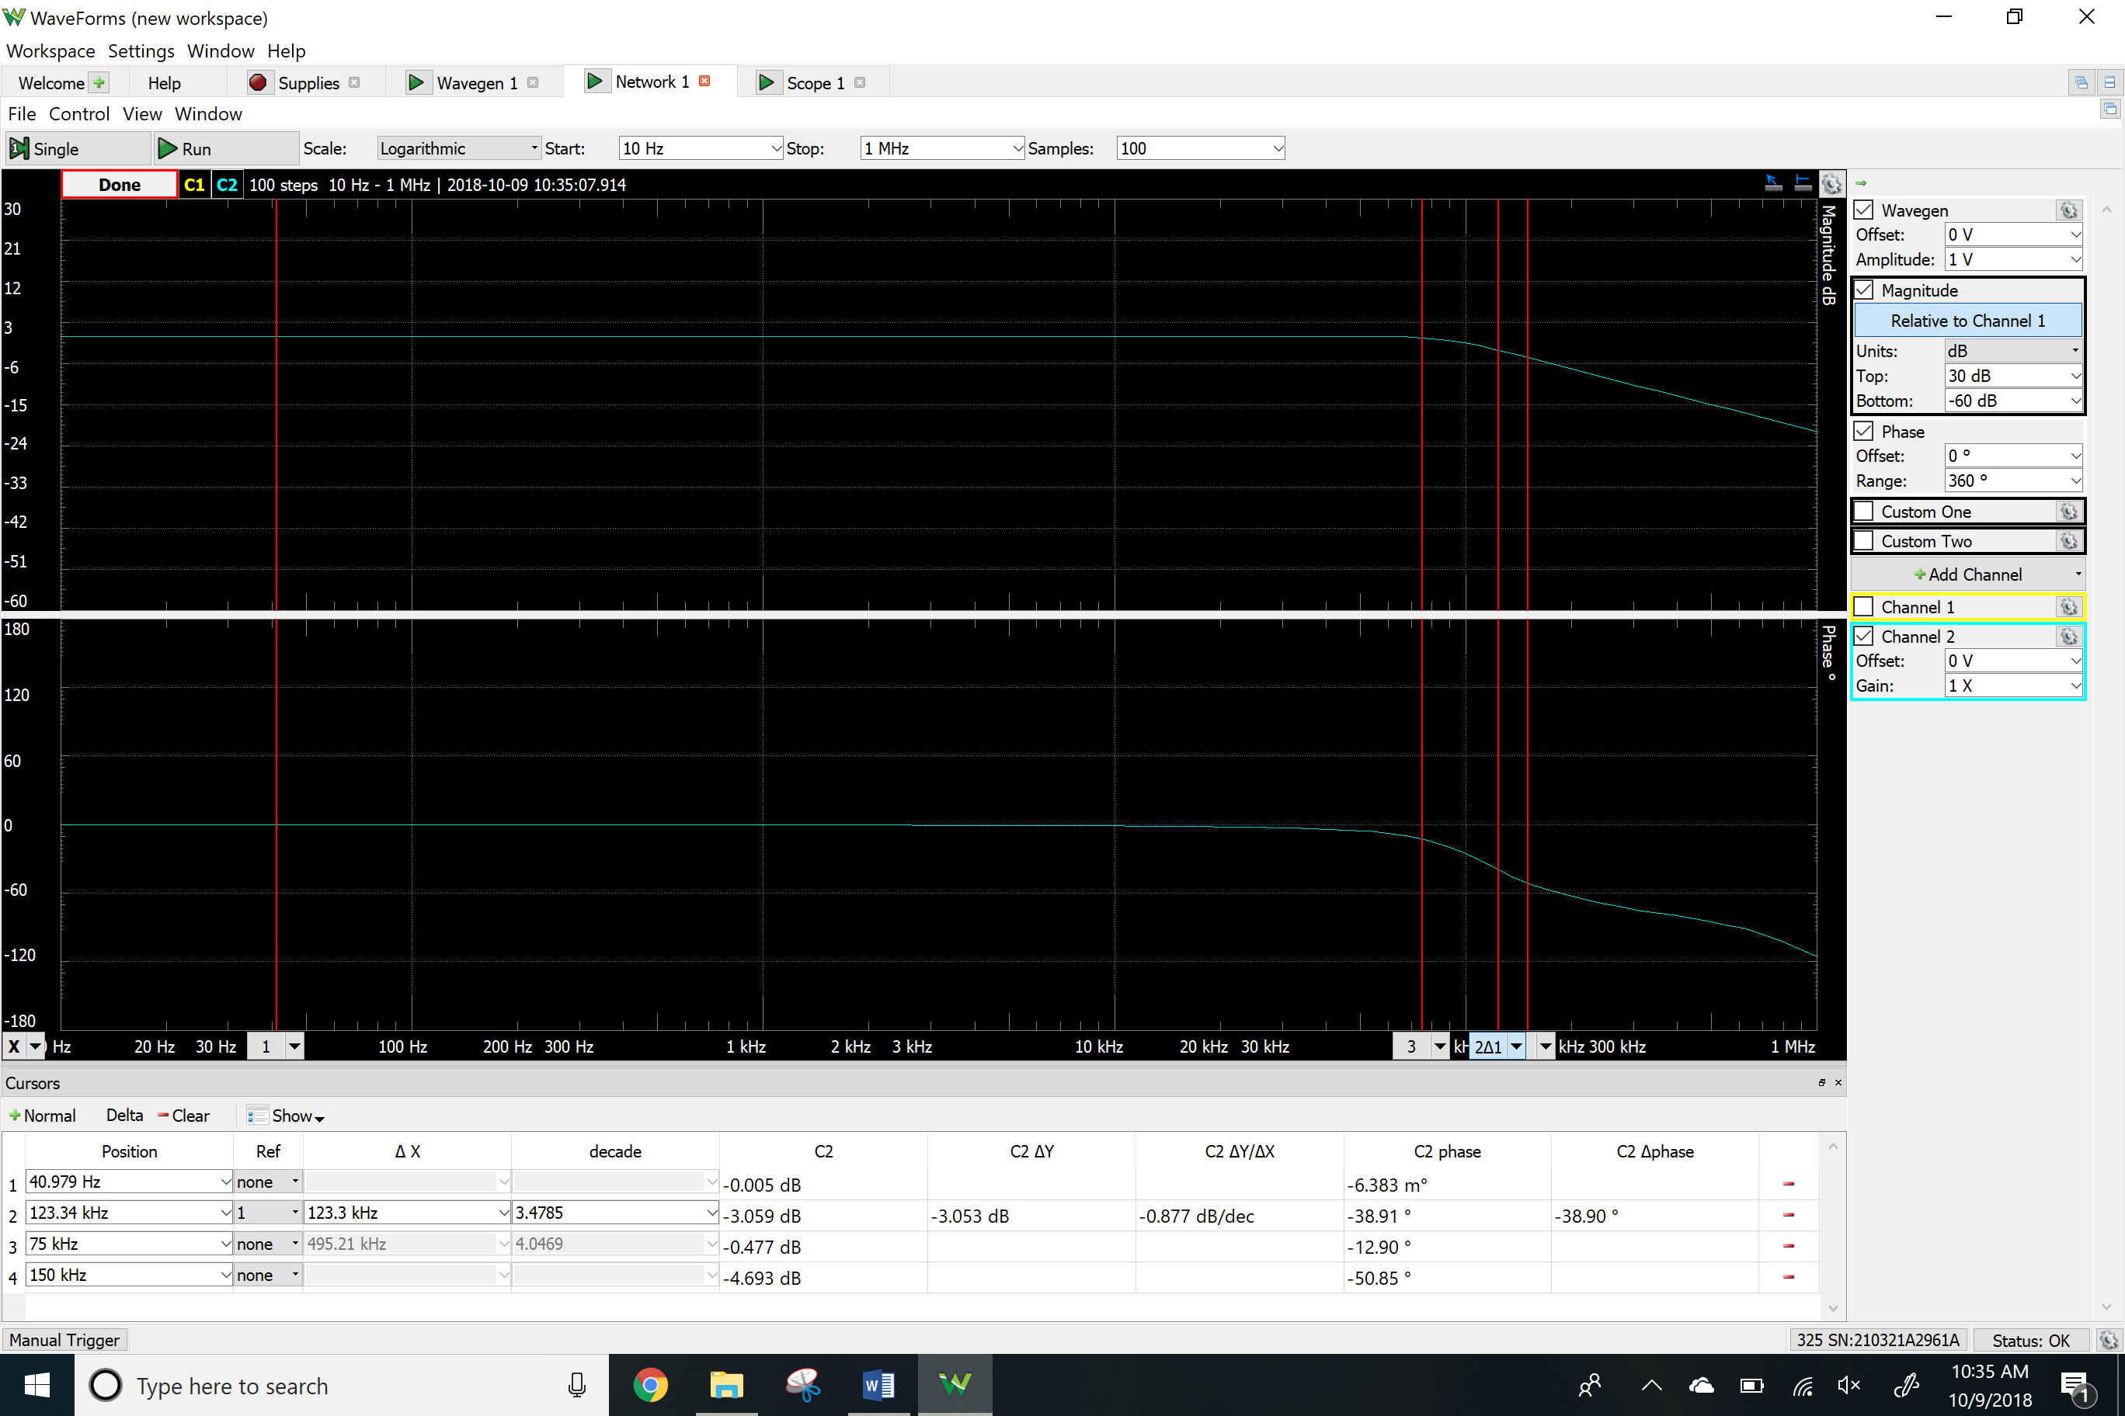

Time-domain waveform: 75 kHz, 1 V

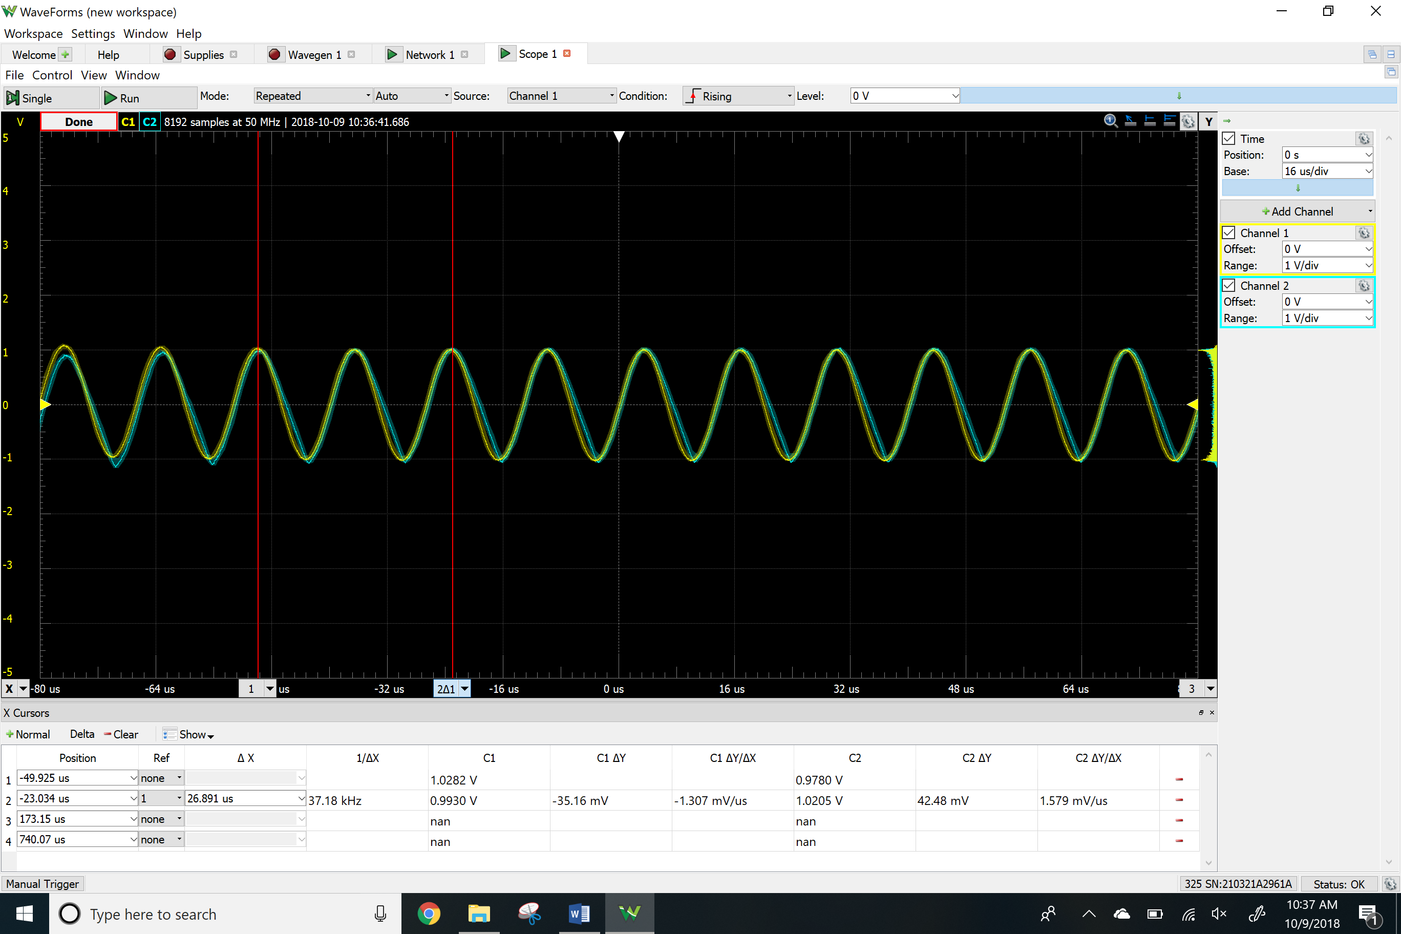

THD: 75 kHz, 1 V

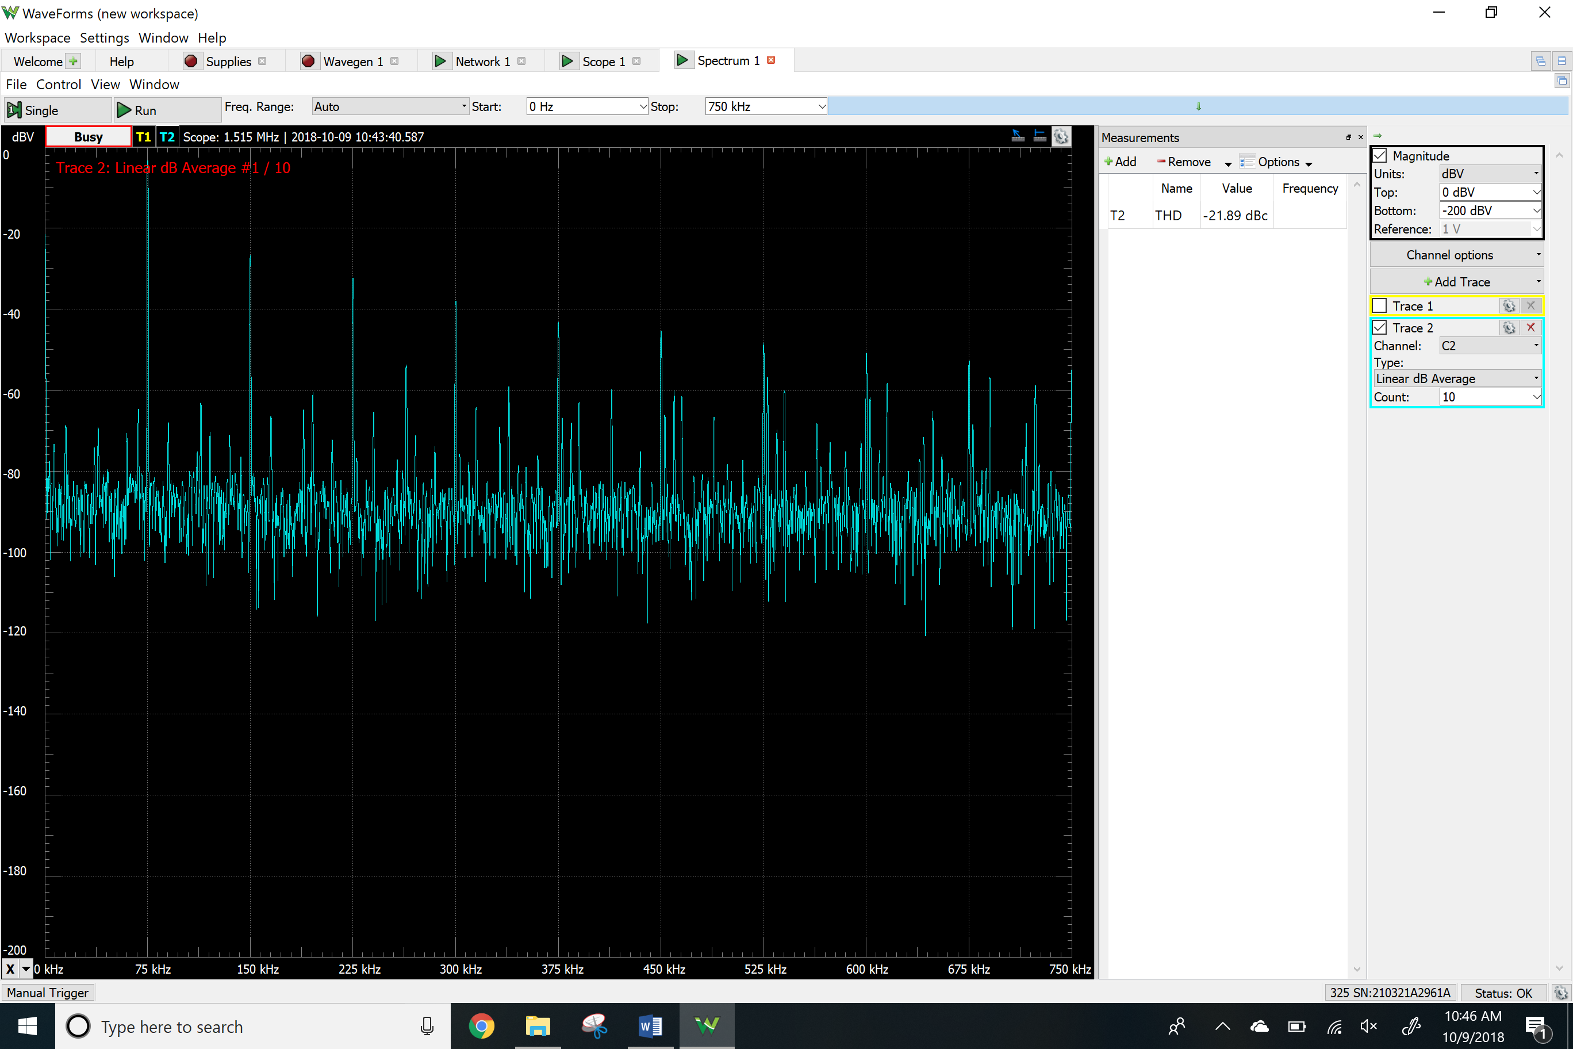

Time-domain waveform: 75 kHz, 2 V

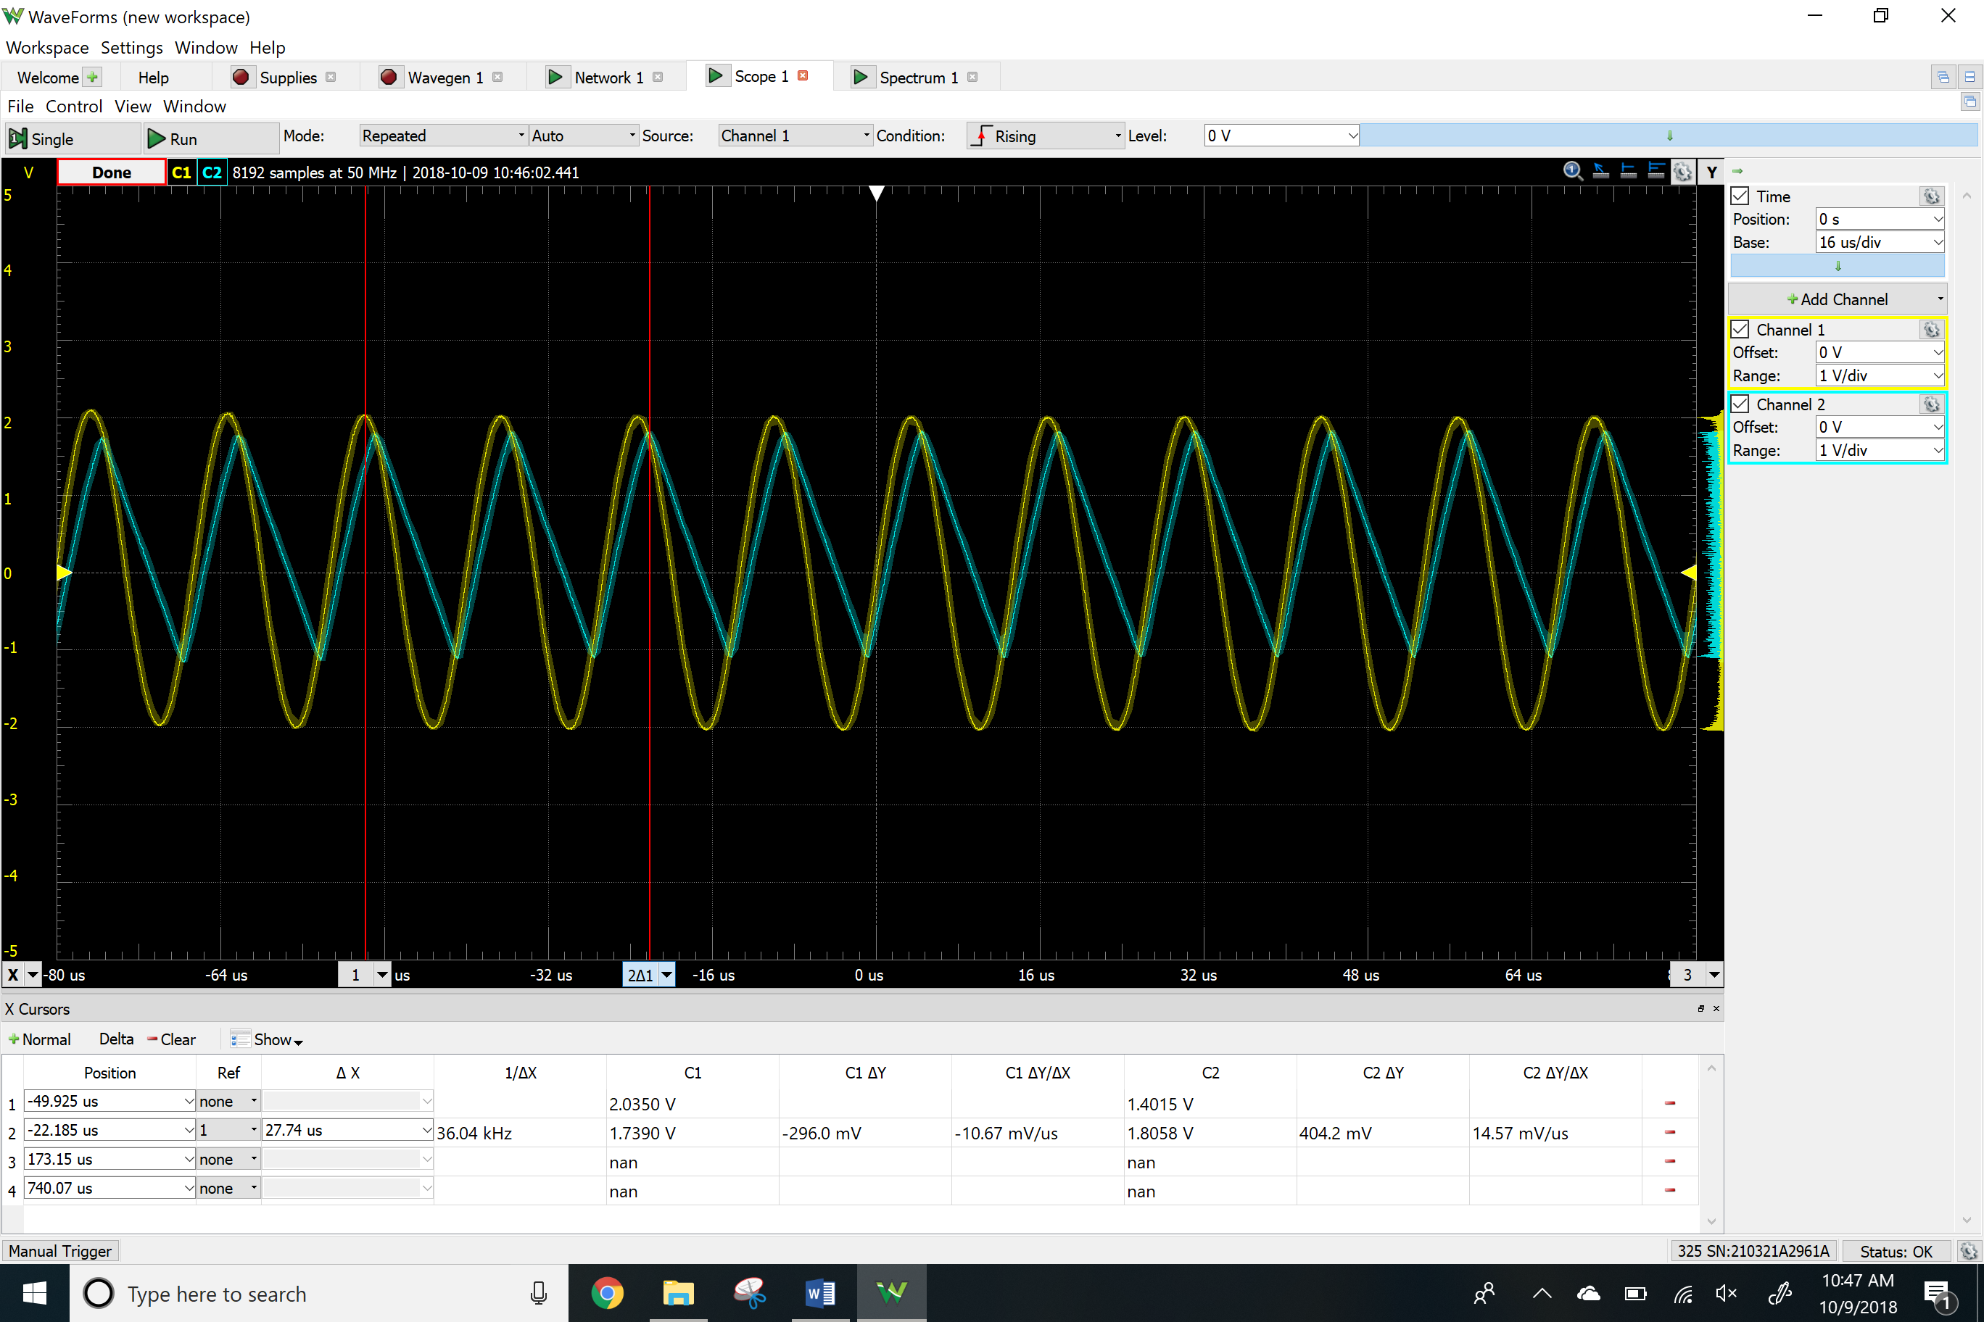

THD: 75 kHz, 2 V

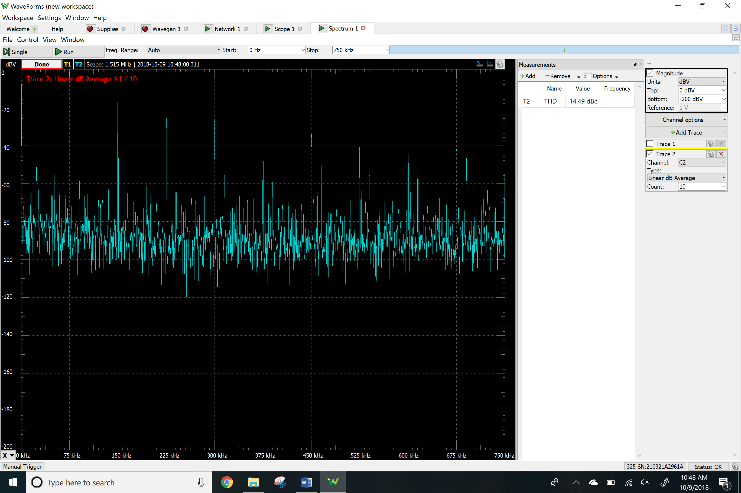

Time-domain waveform: 150 kHz, 1 V

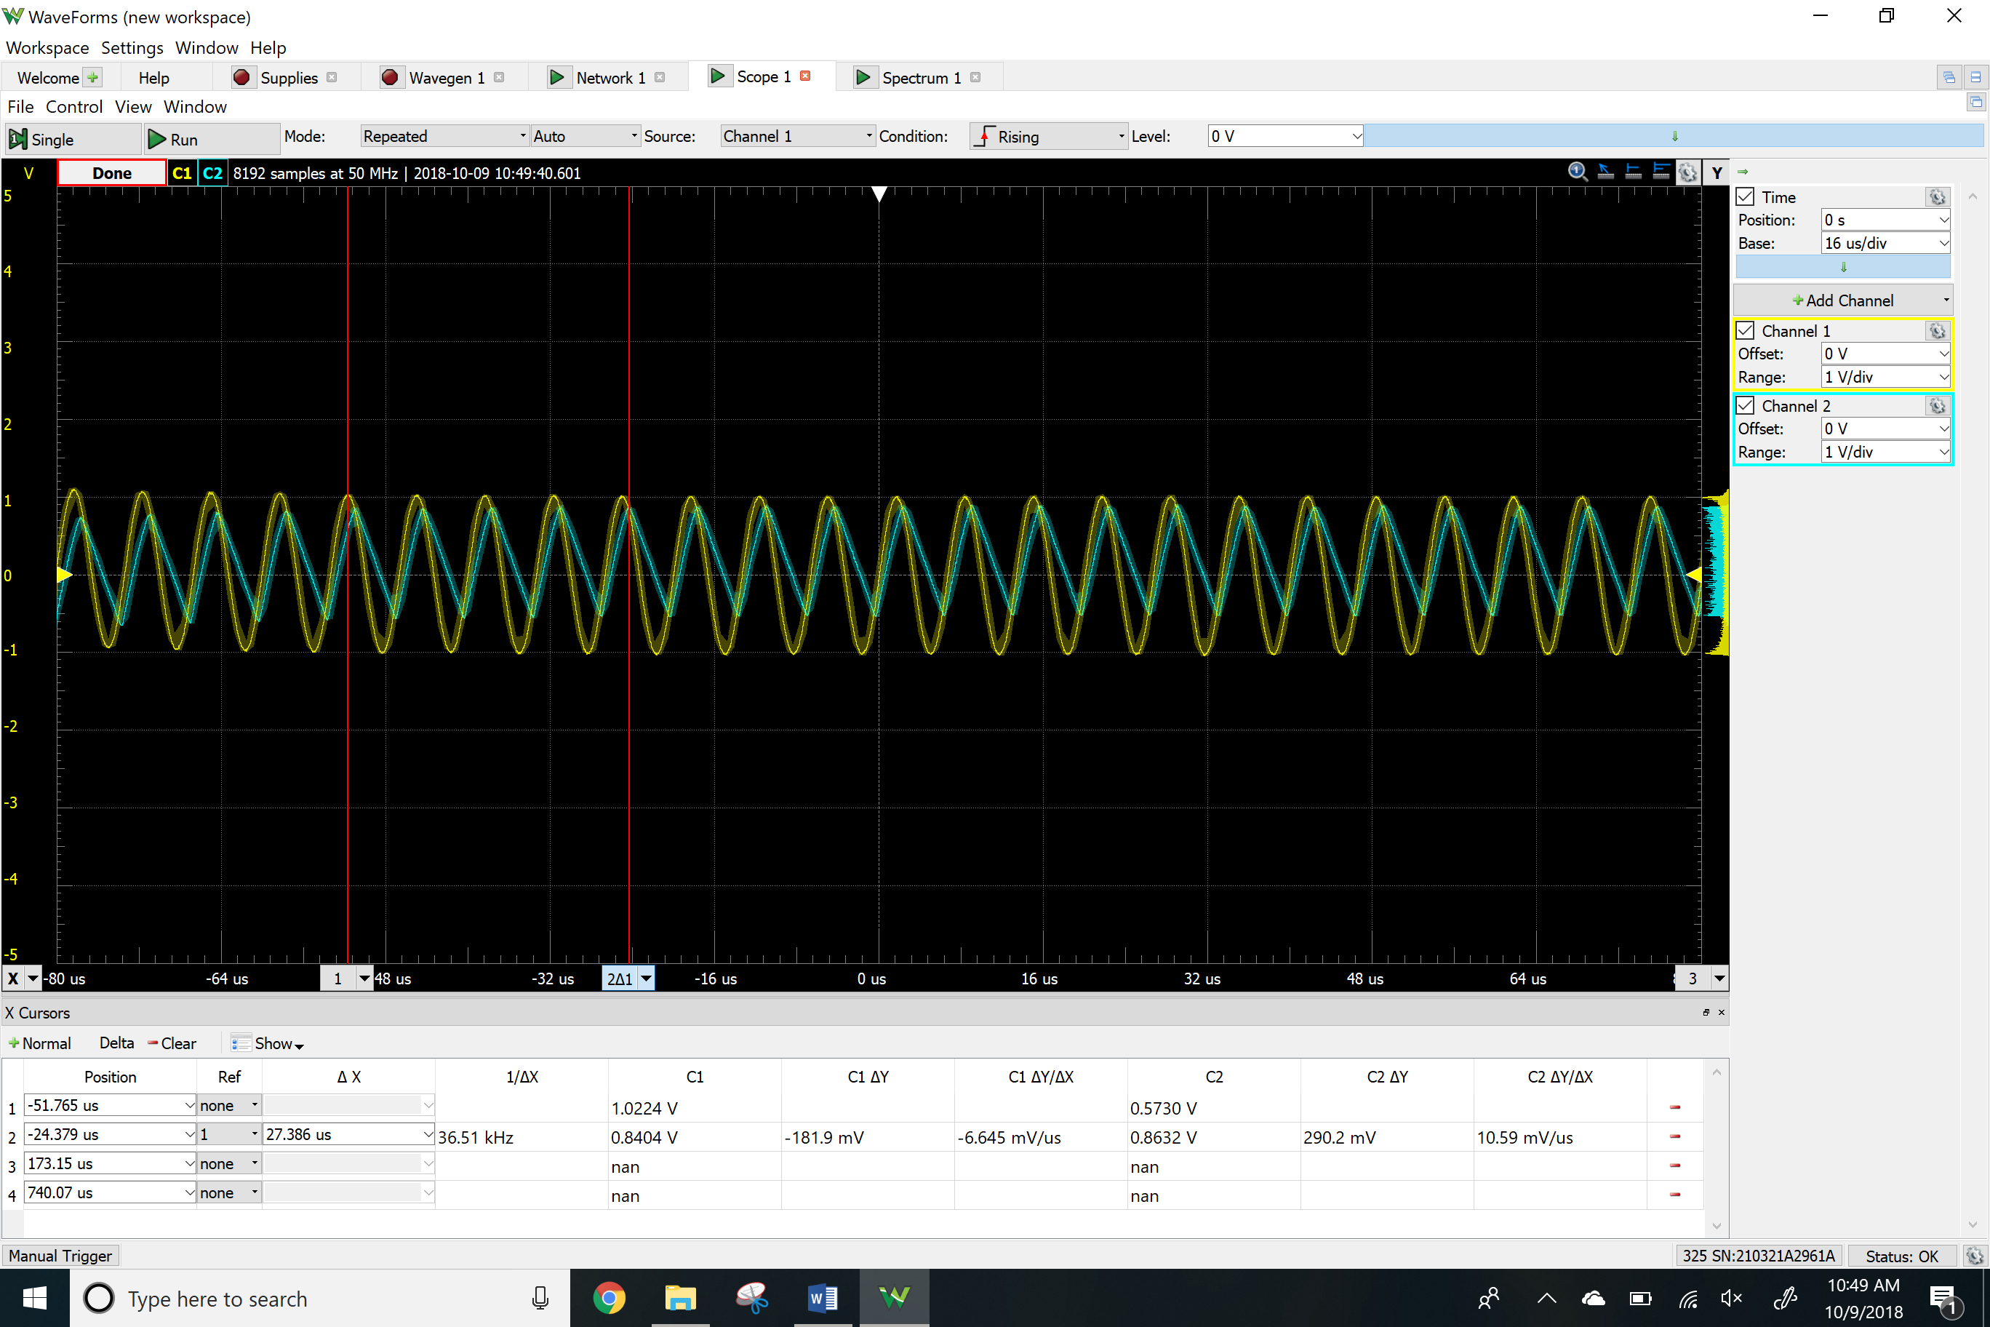

THD: 150 kHz, 1 V

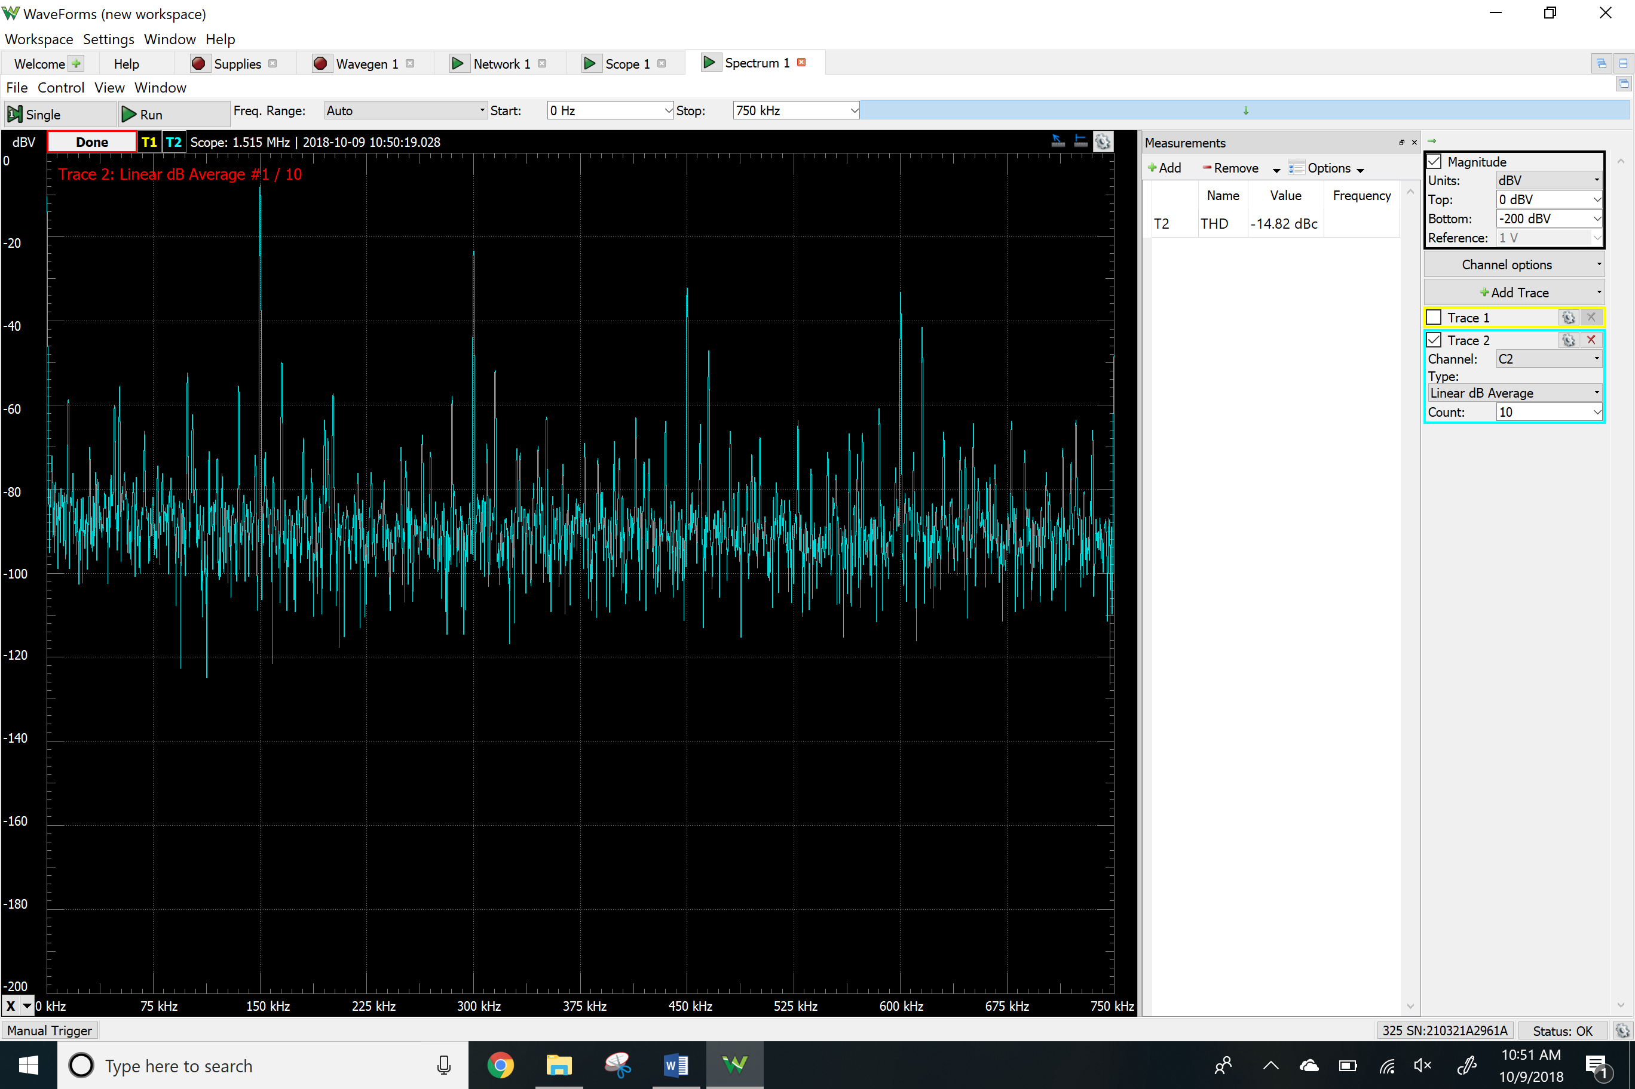

**Results**

**Calculated**

|  |  |  |
| --- | --- | --- |
|  | 3 dB frequency | Amplitude |
| Integrator | 4.75 kHz | -0.36 V |
| Differentiator | 1.31 kHz | 0.09 V |

**Simulated**

Integrator and Differentiator

|  |  |  |
| --- | --- | --- |
|  | Integrator | Differentiator |
| Low frequency gain | 26.83 dB | 26.82 dB |
| 3 dB frequency | 32.96 Hz | 4.469 kHz |
| Mag @ 1 kHz | -2.82 dB | 13.0 dB |
| Phase @ 1 kHz | 91.8 $°$ | -101.8 $°$ |
| Mag of input voltage | 499.7 mV | 99.9 mV |
| Mag of output voltage | 124.1 mV | 450.36 mV |
| Phase difference | 0.75 mS | 0.72 mS |
| Peak to peak output voltage | 0.426 V | 0.290 V |

Finite GBW limitations

|  |  |  |  |
| --- | --- | --- | --- |
|  | Gain = 23 | Gain = 57 | Gain = 83 |
| Low frequency gain | 27.23 dB | 35.11 dB | 38.37 dB |
| 3 dB frequency | 48.05 kHz | 19.06 kHz | 13.28 kHz |

Slew Rate limitations

|  |  |
| --- | --- |
|  | Slew Rate limitations |
| Low frequency gain | -195.55 µdB |
| 3 dB frequency | 1.54 MHz |
| Mag @ 75 kHz | 3.76 µdB |
| Mag @ 150 kHz | 322.36 µdB |
| THD @ 75 kHz, 1 V | 0.63 % |
| THD @ 75 kHz, 2 V | 11.64 % |
| THD @ 150 kHz, 1 V | 11.13 % |

**Measured**

Integrator and Differentiator

|  |  |  |
| --- | --- | --- |
|  | Integrator | Differentiator |
| Low frequency gain | 10.79 dB | 10.78 dB |
| 3 dB frequency | 279.42 Hz | 35.24 kHz |
| Mag @ 1 kHz | -2.67 dB | 10.32 dB |
| Phase @ 1 kHz | 93.2 $°$ | -105 $°$ |
| Mag of input voltage | 0.496 V | 0.096 V |
| Mag of output voltage | 0.528 V | 0.405 V |
| Phase difference | 0.804 mS | 0.292 mS |
| Peak to peak output voltage | 0.565 V | 0.536 V |

Finite GBW limitations

|  |  |  |  |
| --- | --- | --- | --- |
|  | Gain = 23 | Gain = 57 | Gain = 83 |
| Low frequency gain | 10.87 dB | 10.88 dB | 10.89 dB |
| 3 dB frequency | 38.23 kHz | 37.46 kHz | 37.46 kHz |

Slew Rate limitations

|  |  |
| --- | --- |
|  | Slew Rate limitations |
| Low frequency gain | -0.005 dB |
| 3 dB frequency | 123.34 kHz |
| Mag @ 75 kHz | -0.47 dB |
| Mag @ 150 kHz | -4.69 dB |
| THD @ 75 kHz, 1 V | 8.04 % |
| THD @ 75 kHz, 2 V | 18.85 % |
| THD @ 150 kHz, 1 V | 18.15 % |

**Conclusion**

The lab helped me study some of the op amp configurations commonly found in practical applications and also investigate the non-idealities of the op am such as finite Gain-Bandwidth product and slew rate limitations. The circuits studied will include an integrator, a differentiator, a non-inverting amplifier and a unity-gain buffer. I also noticed that the output rises above the threshold when Resistor R2 in the lossy integrator configuration is removed. The results matched the simulated and calculated measurements so the lab went accordingly.